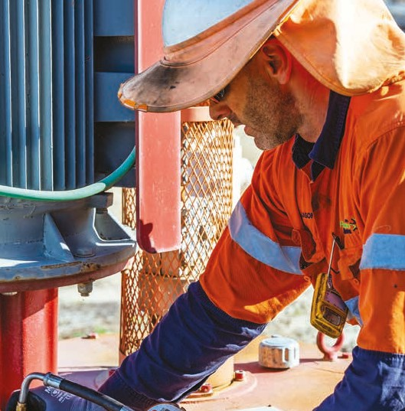
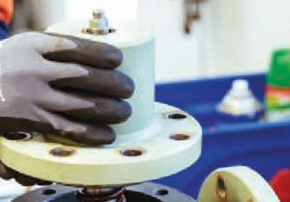
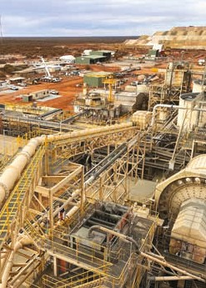

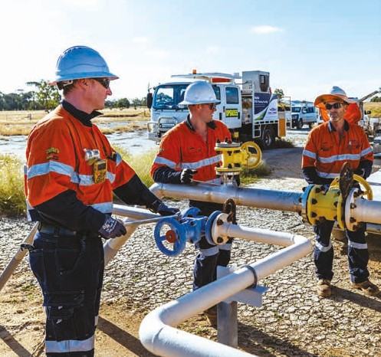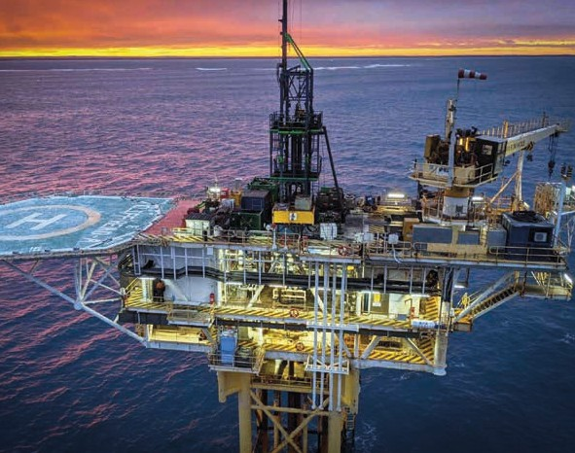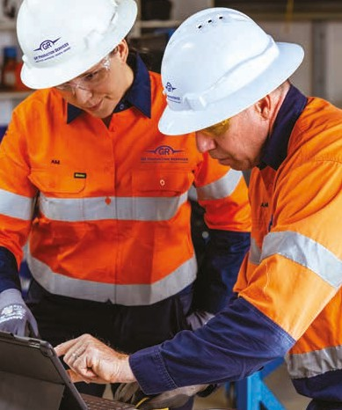

Company Profile

GR Production Services COMPANY PROFILE

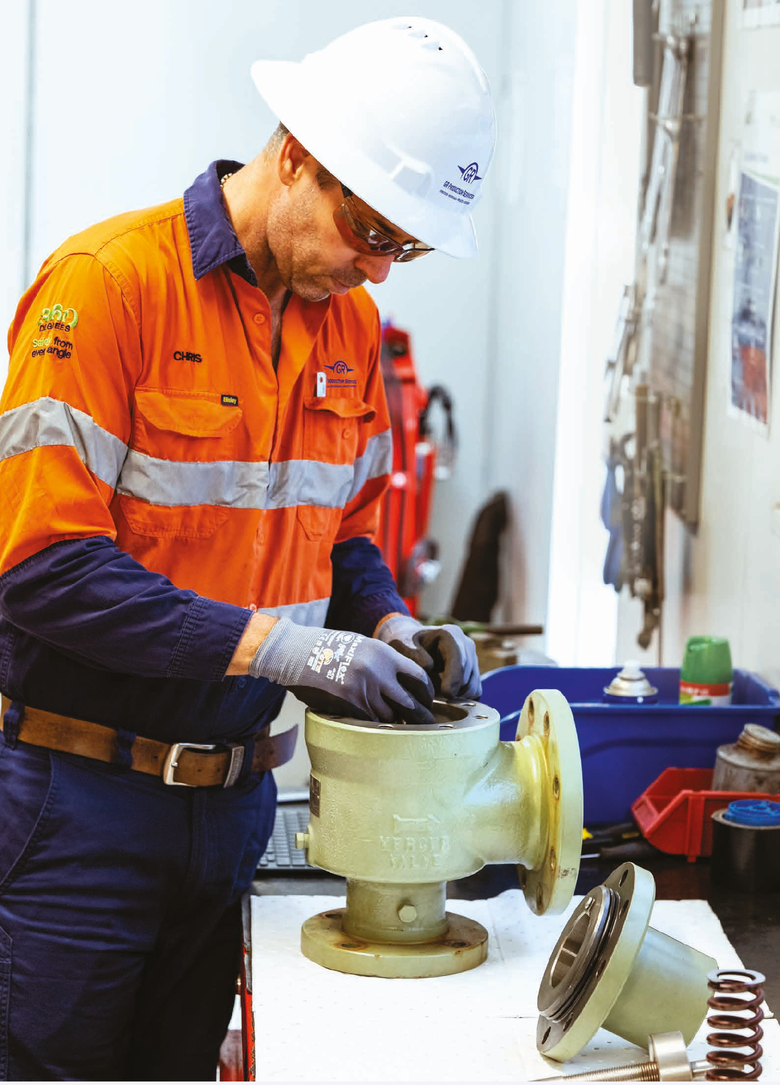
Contents
Introduction 3
Our Commitment 4
The GR Production Services Way 6
Operations 8
Maintenance 10
Projects 12
Advisory 13
Fully Integrated Services 14
Locations 16

A reputation for delivering safe and sustainable production services.

GR Production Services COMPANY PROFILE

GR Production Services is a leading provider of fully integrated, safe and sustainable production solutions to the energy and resources industries.
Our unique position as an independent operator and track record of more than 25 years in operations and maintenance allows us to bring a production mindset to every solution.
With a reputation for delivering safe and sustainable solutions, we work as an integrated team with our clients to enhance HSSEQ, field life, cost performance and optimise production.
We provide fully integrated production solutions, comprising a suite of services tailored to our clients.




OPERATIONS
MAINTENANCE
PROJECTS
ADVISORY

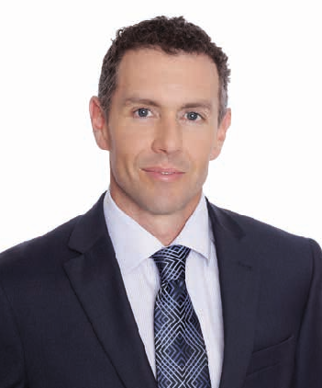
GR Production Services COMPANY PROFILE

Cameron Wills
Chief Executive Officer

Our Commitment
As our business has evolved from its humble beginnings in 1997, we continue to strive for operational excellence in all that we do. The imperative for safe and sustainable production services has never been stronger and remains at the heart of our service offering
as we continue to proudly serve our long-term clients who entrust us with their assets year after year.
A culture of collaboration plays a great part in our success. Working closely with our clients, we have been able to develop innovative practices that deliver against safety, sustainability, cost, productivity and integrity measures.
We are committed to delivering fully integrated production services that add value for our clients, our people and the communities in which we work.
To our people, clients, stakeholders and friends, I thank you for your continued commitment to GR Production Services.

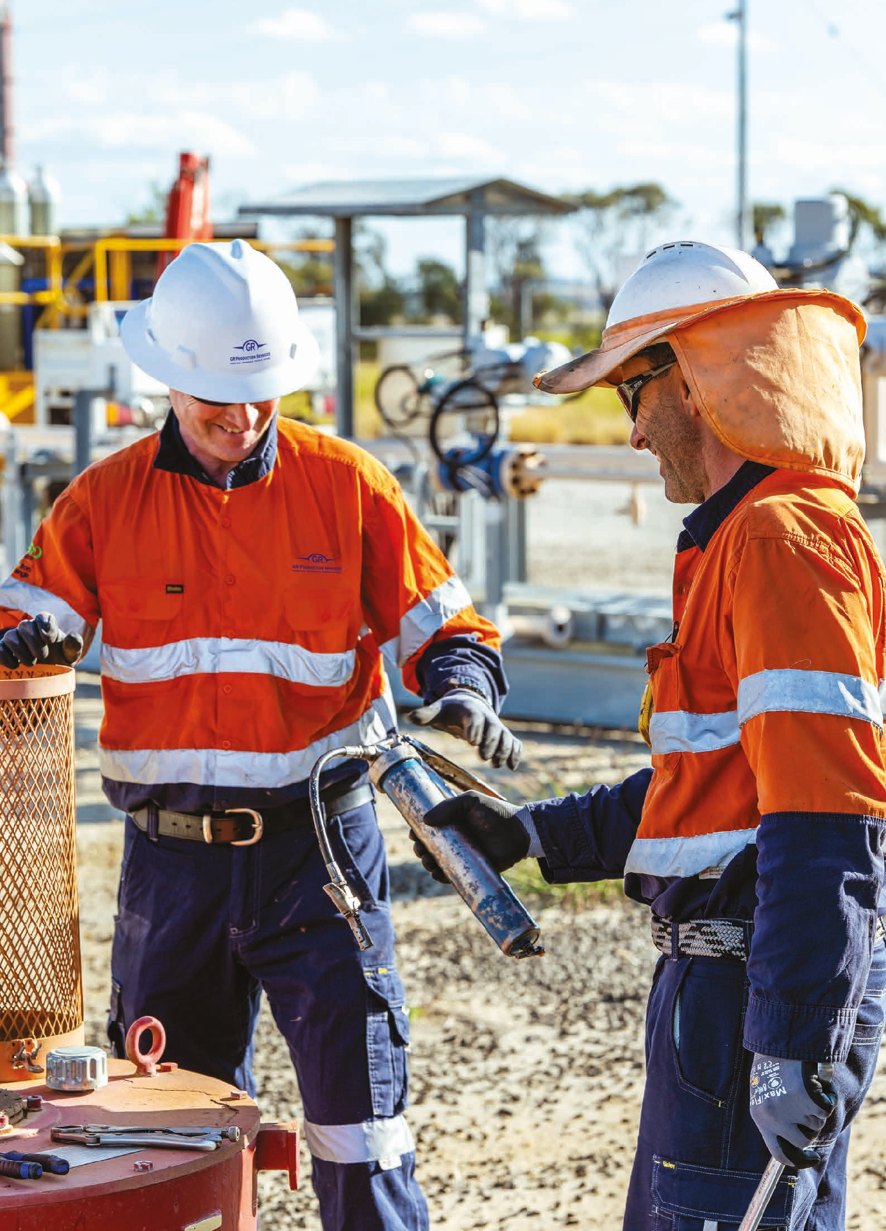
GR Production Services COMPANY PROFILE

Making operations strategies a reality for our clients.





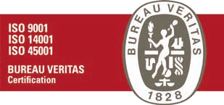
GR Production Services COMPANY PROFILE
C
•
y
t
s
i
l
a
t
u
c
Q
e
&
j
n
o
o
i
t
a
r
v
o
P
n
n
I
t
n
y
e
m
r
n
o
o
r
i
v
s
n
i
E
v
&
d
y
t
i
n
A
u
m
m
o

The GR Production Services Way
The GR Production Services Core Values are the DNA of our business, reflecting our strong safety culture and effective working relationships, respecting the culture, diversity and values of others.
They support our vision, “To be a leading provider of fully integrated operations, maintenance, projects and advisory services, adding value for our clients, our people and the communities in which we work”.
Our Integrated Management System (IMS) enables delivery of safe, sustainable and high-quality solutions to our clients. It provides a safe and healthy workplace for our people, as an environmentally responsible member of the community. It is a platform that demonstrates our Core Values and allows us to follow through on commitments to our clients, our people and the community.
Up to date with the latest industry and regulatory requirements, the IMS is certified by independent, internationally accepted bodies. The IMS complies with national and international standards of HSEQ Management.
Our Core e
n
t
F
o
c
u
s
o
p
l
e
•
C
l
i
Values
M
a
i
•
n
t
H
o
e
n
e
n
s
t
a
y
&
n
I
n
c
t
e
e
g
r
•
i
t
y
H
e
•
a
l
t
h
O
&
p
S
a
e
f
e
t
r
y
a
•
t
i
P
e
o
n
s





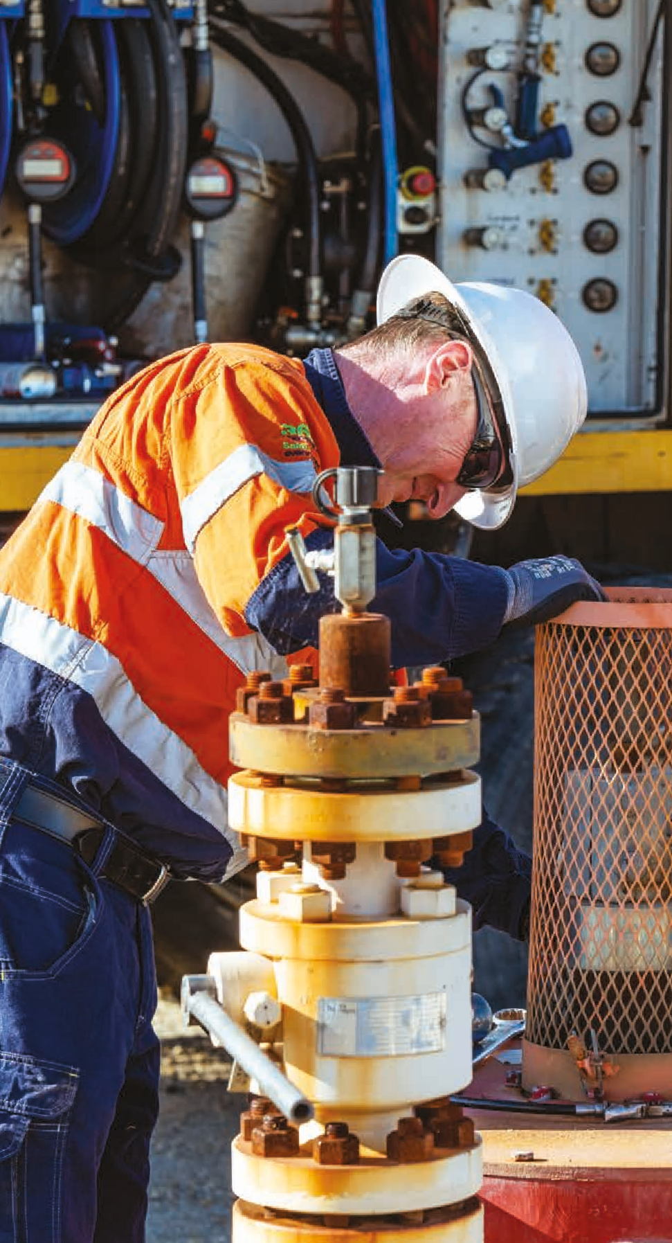
We are committed to achieving zero injuries across our business and underpinning this is our safety culture program; 360 DEGREES: Safety from every angle.
GR Production Services COMPANY PROFILE
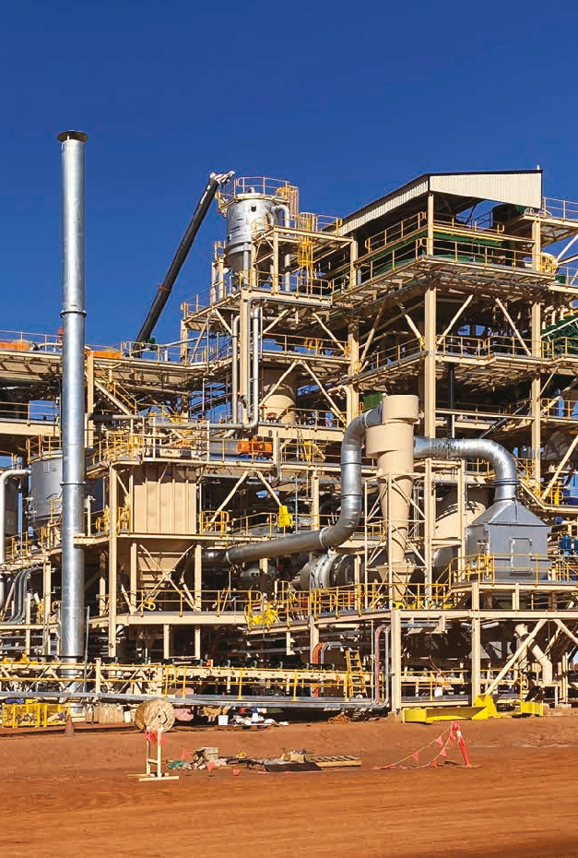
Our number one goal is for everyone to return home from work safely.
The program encourages proactive thinking about safety from every angle before proceeding with any task. By taking personal responsibility for our own safety and the safety
of our workmates every day, we believe Zero Harm is achievable at GR Production Services.

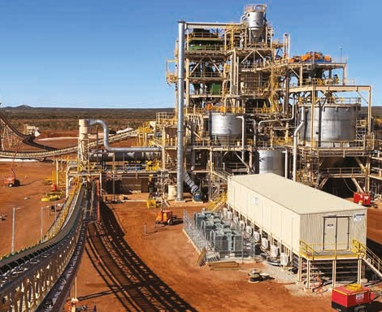
GR Production Services COMPANY PROFILE


Operations

Making Operations Strategies a Reality

At GR Production Services we have an excellent track record and experience operating production facilities across the Energy and Resources industries.
Supporting early development of Australian resource projects, we are at the forefront of well optimisation and ground-breaking carbon capture, utilisation and storage (CCUS), as well as Hydrogen Production Facility Operations & Maintenance experience.
We provide operation services to new energy infrastructure, as our clients embark on the journey towards net zero emissions by 2050.
We work seamlessly with organisations across all phases of the asset lifecycle, continually seeking solutions to deliver technical and commercial success.
We focus on safely maximising profits for our clients by optimising production and minimising deferments while protecting long term asset integrity.
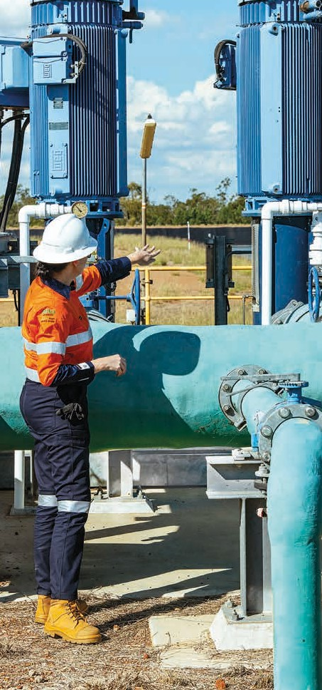
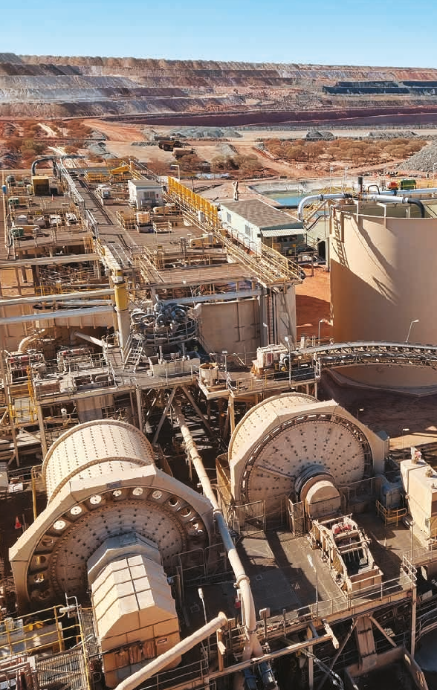
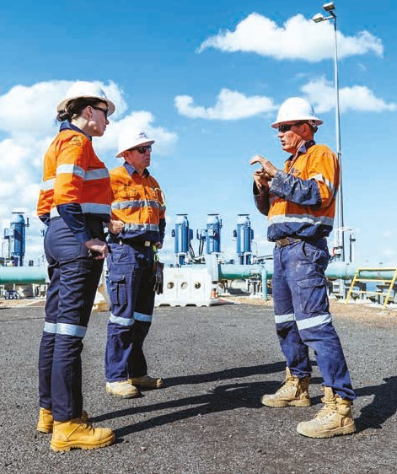
We have over twenty five years of experience holding safety cases (onshore and offshore), and we understand the requirements of different facilities and jurisdictions.

GR Production Services COMPANY PROFILE

Our comprehensive range of operations services include:

- Facility and field operations across energy and resource projects
- Operations management and field support
- Integrated Management System (IMS) and HSE Management System (HSE-MS)
- Independent registered operator service
- Full crewing services for onshore and offshore facilities

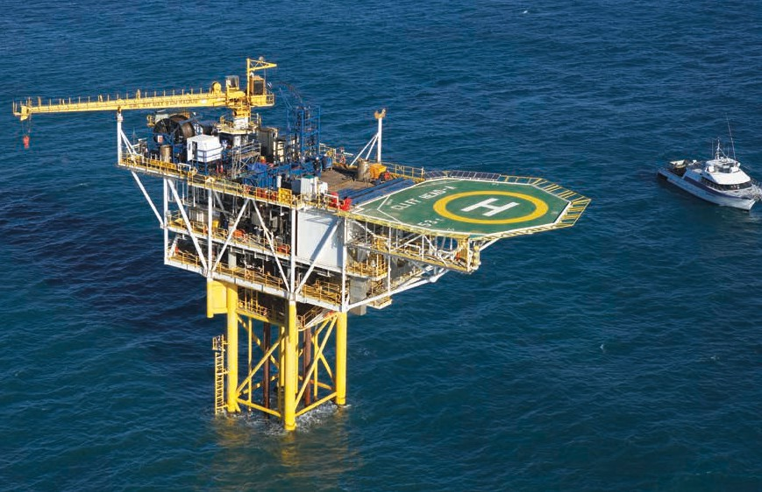
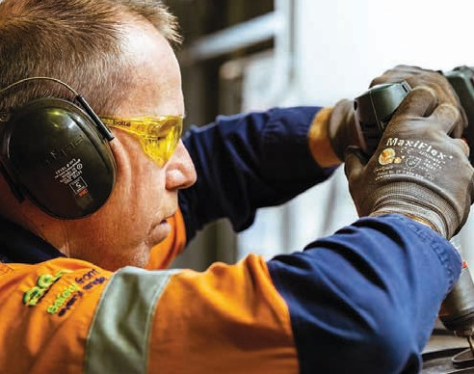
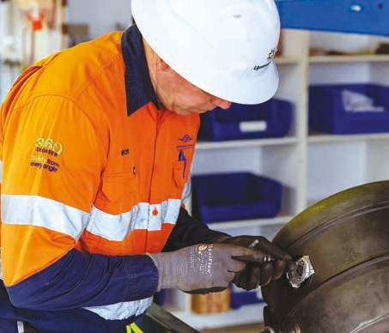
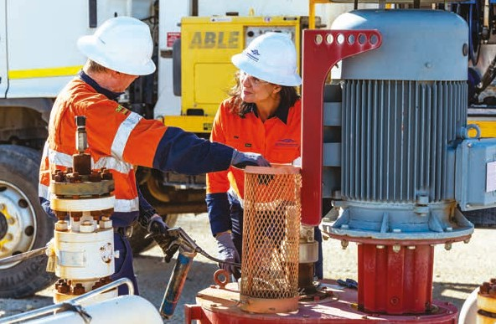

When we combine organisational alignment, lessons learned, our ISO certified systems, people and safety culture – we provide a solid foundation for success; and deliver on our promise of fully integrated production solutions.


GR Production Services COMPANY PROFILE

Maintenance

Culture, Capability and Continuous Improvement

GR Production Services have been providing maintenance support services to clients across the Australian energy and resources sector for more than 25 years, ensuring client facilities run reliably and at optimal cost.
Our range of services include:
- Maintenance execution, management and equipment support
- Turnaround management and delivery
- Specialist maintenance services
- Rotating equipment servicing
- Information capture and analysis, supporting sustainable continuous improvement.
- PSV recertification
- Flange management
- Well servicing
- Pump maintenance
- HV switching and maintenance
- Equipment hire – general trade tools, specialist testing, access equipment, vehicles, mobile containerised workshops
- Waste management services – vacuum loading, pot holing and high pressure jetting

At GR Production Services continuous improvement is central to our maintenance philosophy. Following the key stages of Plan, Operate, Maintain and Optimise leads to positive outcomes for our clients and stakeholders with no surprises.

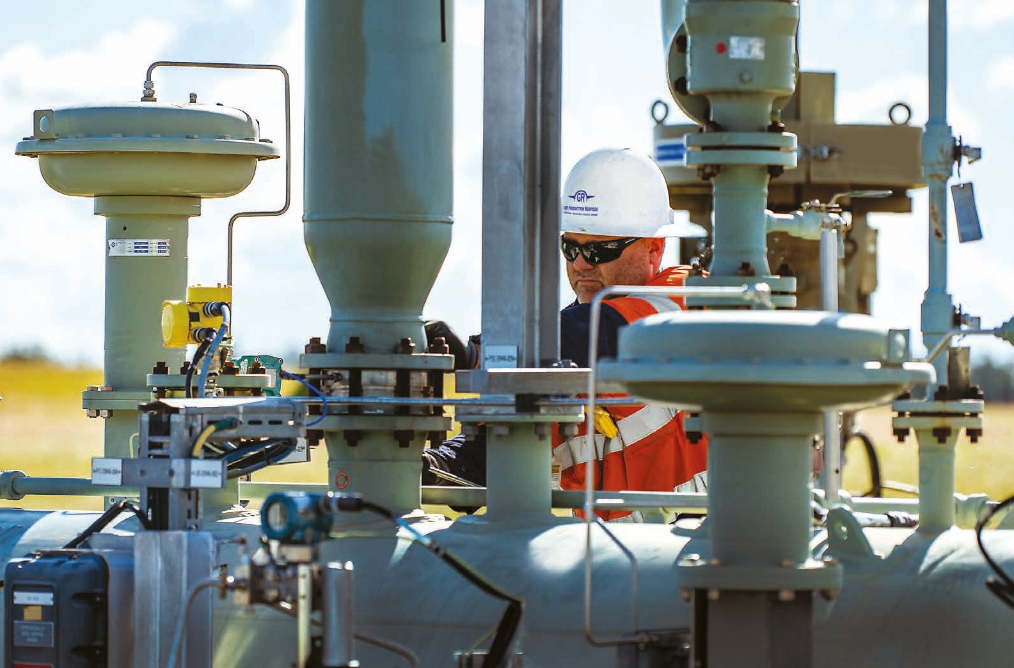
GR Production Services COMPANY PROFILE
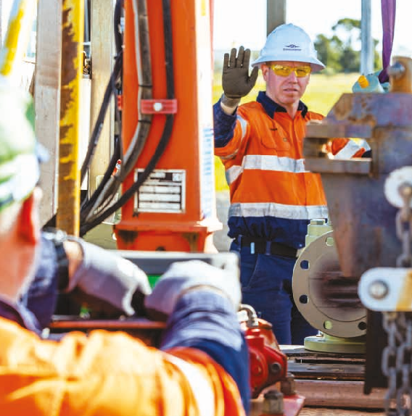
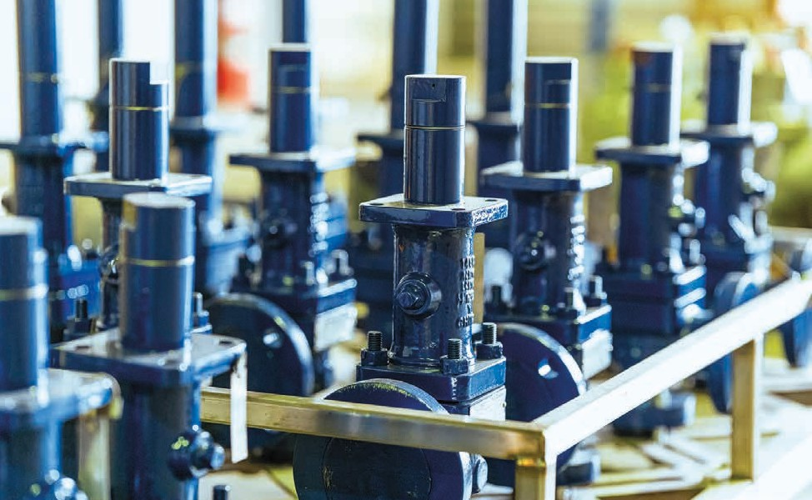
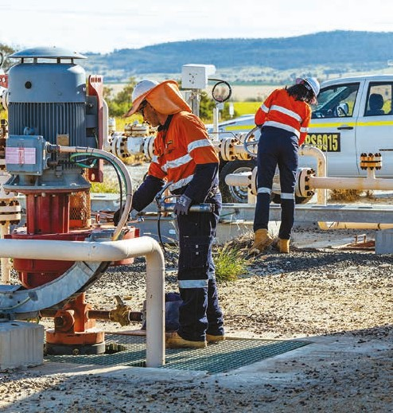
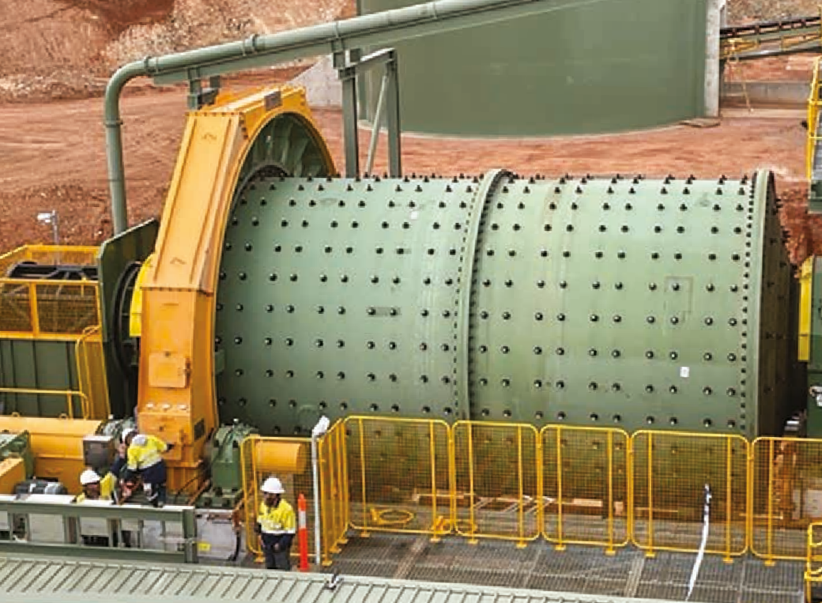

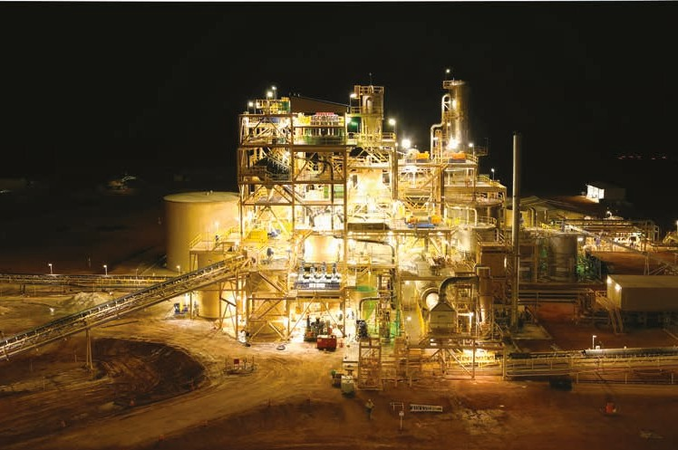
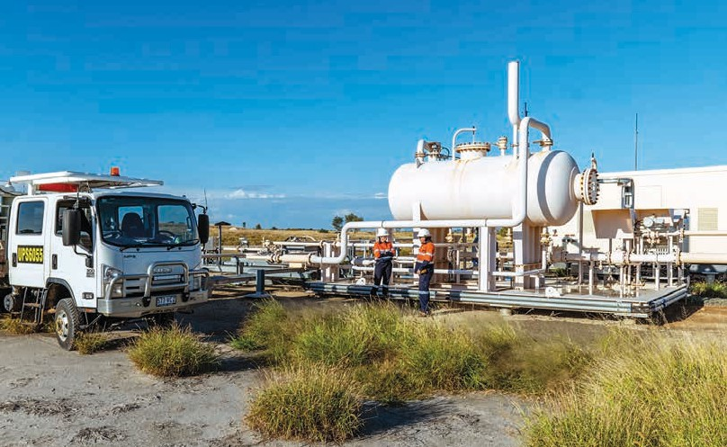
GR Production Services COMPANY PROFILE

Projects

Delivered with a Production Performance Mindset

Our multi-disciplined team of engineers and project managers support clients throughout each stage of the asset/project lifecycle.
We provide a wide variety of project services supported by engineering from minor modifications to major facility upgrades.
Our operations and maintenance experience provides valuable insights into design, with our team working from concept through to installation, commissioning and operations.
Our range of EPC and project management services include:
- Engineering projects and field development
- Well delivery and workover management
- Subsea inspection, maintenance and repair
- Decommissioning
- Technology and innovation
- Specialist fabrication, assembly, instrumentation and installation

Procurement, logistics and supply chain are the engine room of converting innovative design into a quality, on-time, cost effective solution. Long term relationships with key suppliers are key to the delivery of quality projects.
Our procurement and project management systems make sure cost, schedule and quality is highly visible and monitored.

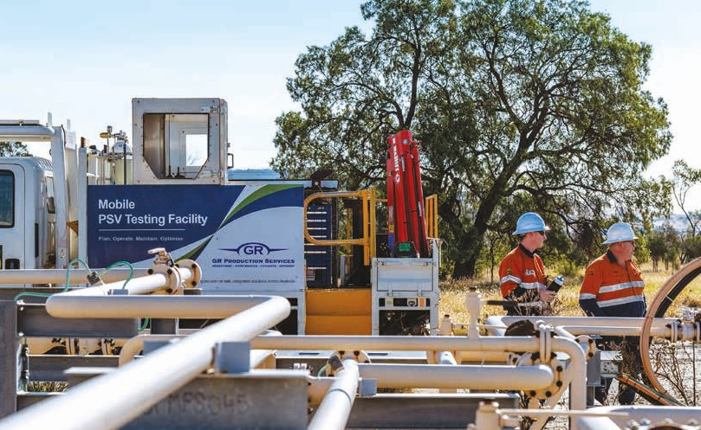
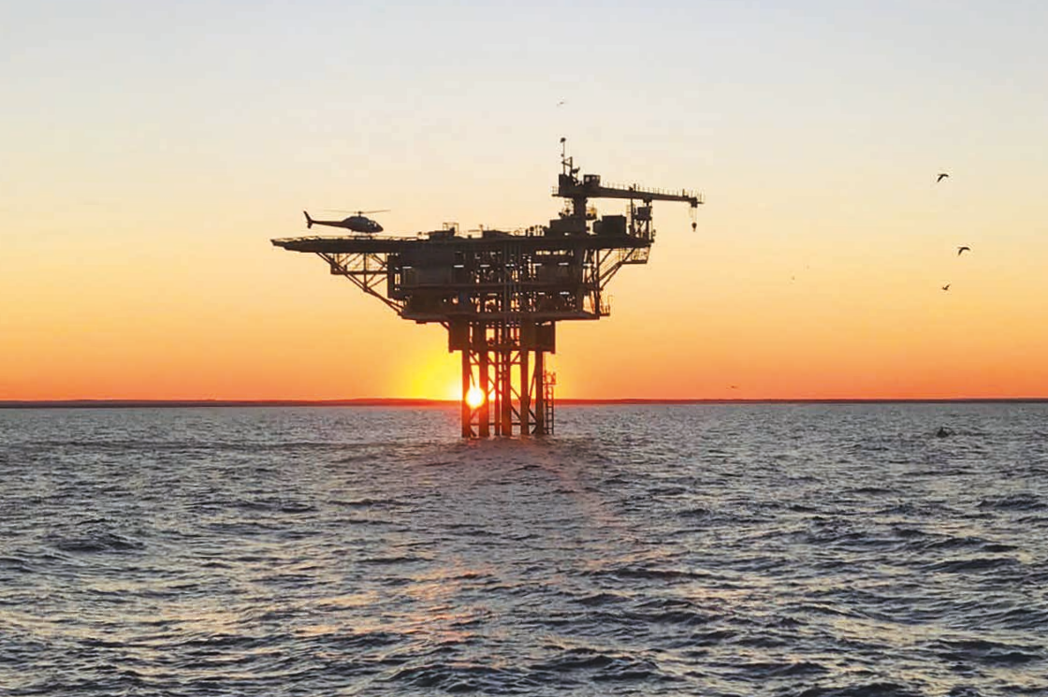

GR Production Services COMPANY PROFILE

Advisory

We Bring Your Asset Into Focus

We work closely with our clients to bring a production mindset. We develop innovative practices to support outcomes that deliver against expected safety, sustainability, cost, productivity, maintenance and integrity measures. This culture of collaboration has been key to our successful history.
Our network of energy and resources professionals provide flexible advisory services backed by the credibility of GR Production Services.
- Consultant support
- Maintenance / OPEX optimisation studies
- 4Ds – Discover, Define, Design, Deploy
- Operations excellence
- Due diligence assessments
- Non-Operator JV support
- Risk assessments
- Regulatory approvals
- Operation readiness and assurance
- Transition services
- Industrial relations

GR Production Services COMPANY PROFILE

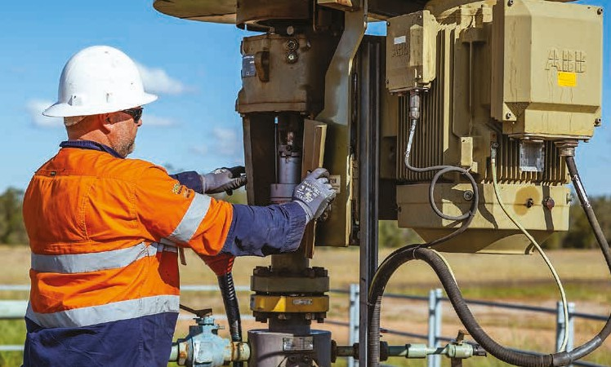
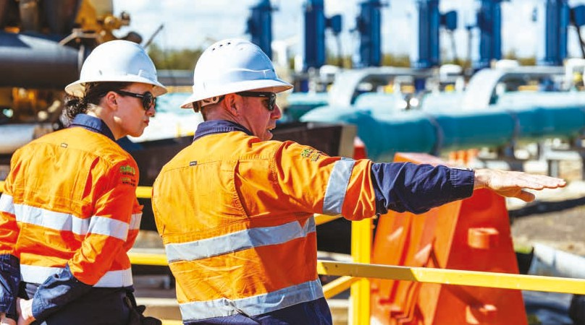




Fully Integrated Services

Contract Operations

Offshore & Onshore Operations
Offshore & Onshore
Maintenance Services

Wellsite Maintenance

Personnel Provision

Turnaround Management

Registered Operator
a
r
a
t
i
o
n
Rotating Equipment Maintenance

Flexible Operating Models
M
e
s

HSSEQ, Risk & Emergency Management
lnlec Services, incl. EEHA & HV Maintenance

PSV Certification Flange Manage- ment Pressure Testing
i
n
t
e
n
a
n
c
e

Engineering
O
p

Operations Excellence
y

Commissioning & Start-Up
c
e
j
o
r
P
r
o
s
i
v
d

Project & Planning Services
Operations Readiness & Assurance

Procurement & Logistics
s
t
A

Project Management

Marine Engineering/ Classification Society Engagement

Decom- missioning

Ownership Transition

Regulatory Engagement & Approvals

Due Diligence

GR Production Services COMPANY PROFILE

Operate, Maintain, EPC, Advisory.

APLNG 4 Yearly Turnarounds (15 consecutive shutdowns) Location: Surat Basin, QLD
Shutdown and turnaround management and execution for 15 gas production trains. This project ensures compliance of GPF safety critical equipment against client and regulatory requirements.
APLNG Wellsites
Location: Surat Basin, QLD
Efficient maintenance servicing of 2500 wells over six remote sites. Productivity innovations including on-site PSV testing, mobile scaffold, waste management and multi skilled maintainers.
APLNG Balance of Plant Location: Surat Basin, QLD
Maintenance, modifications and repair for existing and new facilities, including gas processing, water gathering systems and water treatment facilities. Our multi-disciplined project and maintenance team continues to exceed performance targets.
GLNG Wellsites
Location: Surat Basin, QLD
Scheduled and unscheduled maintenance and associated services for the current network of wellsite facilities in the Surat Basin and southern Bowen Basins.
Blacktip Offshore Platform and Yelcherr Gas Plant
Location: Bonaparte Basin, NT
Providing maintenance for the Blacktip facilities, including all routine and campaign maintenance of the wellhead platform, single point mooring and the
onshore gas facility. Additional services include transition execution, shutdowns / turnarounds, planning, CMMS (SAP) entry and management.
Onshore Perth Basin Location: Perth Basin, WA
Operation of seven sites on behalf of the client, including maintenance and facilities engineering.
The Otway Project Location: Otway Basin, VIC
Fully integrated lifecycle support of world leading carbon capture and storage project, including design, procurement contracts, drilling management, facilities installation, commissioning, operations and ongoing maintenance of wells and surface process equipment.
ENEOS
Location: Bulwer Island, QLD
Completion of successful operations readiness (audits, procedures, controls and team competency focus).
Ongoing operations support to the fully commissioned Green Hydrogen Pilot Plant Facility under our GRPS IMS including PTW.
Queensland Pacific Metals Energy Location: Bowen Basin, QLD
Completion of successful transition advisory services, for transfer of operator-ship of Moranbah Gas Plant. Operations readiness, audits, HAZOP, HAZID, systems, process, procedure review. Awarded operations and maintenance provider of the MGP mid 2023.
QGC
Location: Curtis Island, QLD
Designed and developed portable separator packages, inclusive of flare module and solar powered Programmable Logic Controller (PLC) based Remote
Telemetry Units (RTUs). Fabricated, tested and available for installation in under 12 weeks, and installed and commissioned on-site in under 12 hours.
Sumitomo
Location: Brisbane, QLD




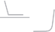




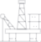


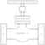
Provision of operations advisory services for detailed design phase of Green Hydrogen project.
Operate
Advisory
Maintain
EPC

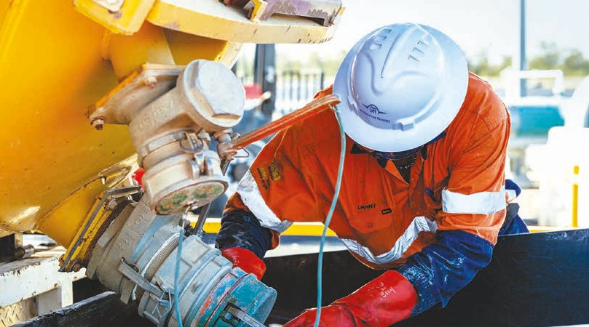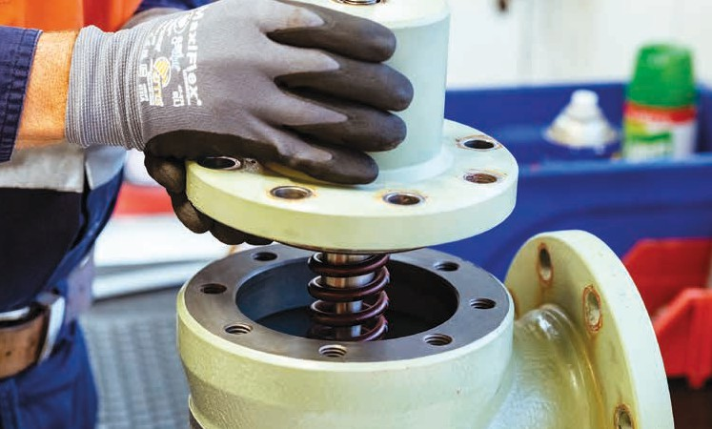


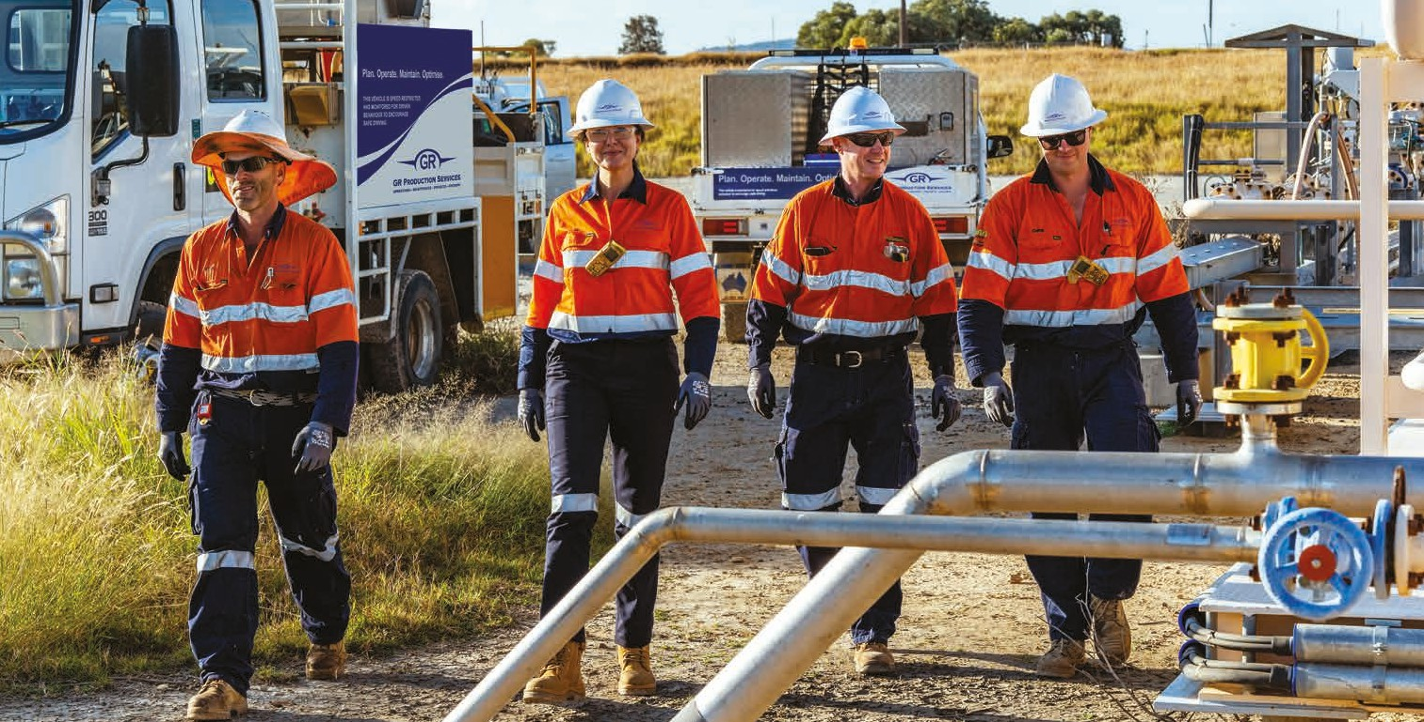
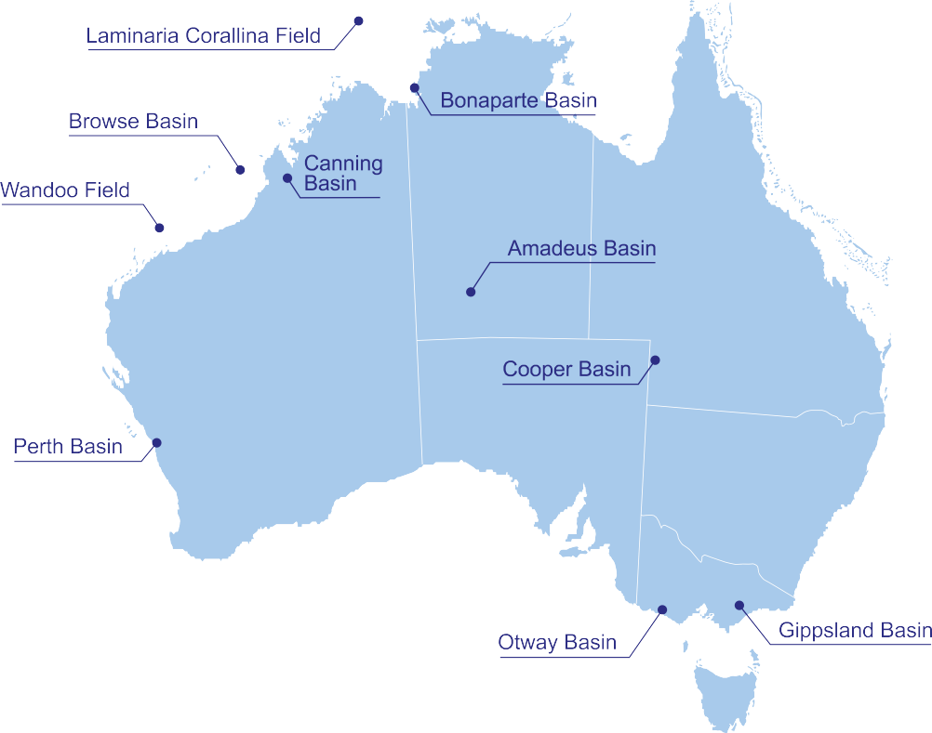








Locations

About Us
GR Production Services is a leading provider of operations, maintenance, projects and advisory services with a reputation for providing safe, innovative and sustainable solutions.
grps.com.au info@grps.com.au

