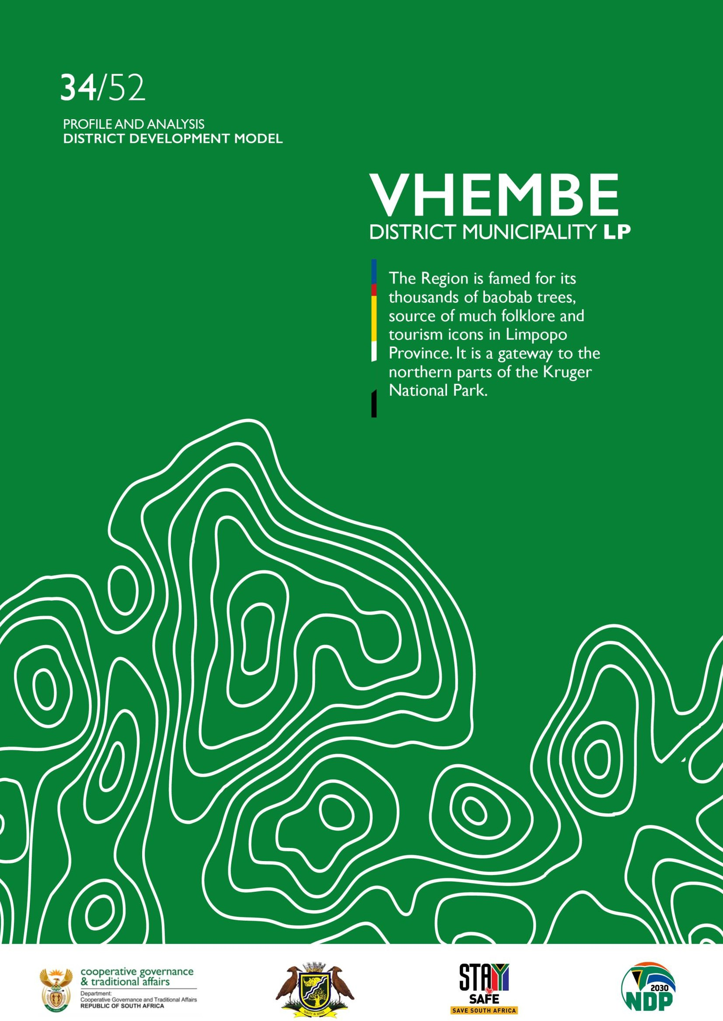



2

PROFILE: VHEMBE DISTRICT MUNICIPALITY


PROFILE: VHEMBE DISTRICT MUNICIPALITY
3

Table of Contents
- EXECUTIVE SUMMARY 6
- INTRODUCTION 8
  - Location 8
  - Historical Perspective 8
  - Spatial Status 9
- SOCIAL DEVELOPMENT PROFILE 9
  - Key Social Demographics 9
    - Population 9
    - Race Gender and Age 10
    - Households 11
      - Child Headed 12
      - Women Headed Households 12
  - Health Profile 12
  - COVID 19 13
  - Poverty Dimensions 15
    - Distribution 15
    - Inequality 16
    - Employed/Unemployed 16
    - Crime 17
  - Education and skills profile 18
- DRIVERS OF ECONOMY 19
  - Structure of the economy 19
  - Primary Sector 19
  - Secondary Sector 20
  - Tertiary Sector 21
  - Informal Trading 22
    - Informal Economy 22
- SERVICE DELIVERY Error! Bookmark not defined.
  - Water and sanitation 24
    - Water 24
    - Sanitation 25
  - Human Settlements 25
  - Waste Management 26
  - Roads and transport 27
  - Electricity 27
- GOVERNACE AND MANAGEMENT 28
  - Municipality Performance 28
  - Municipality Capacity 28
  - Traditional Affairs Governance 29
- PROJECTS TO DIVERS IFY AND GROW PEOPLE AND THE ECONOMY 30
  - Social Development Projects 30
  - Spatial Development 31
  - Infrastructure Projects 32
  - Economic Projects 33
  - Environmental Forecast 33
Climate Change 33
- KEY RECOMMENDATIONS 34
  - Prioritise Integrated Development Plan 34
  - Investor and Sponsorship opportunities 34

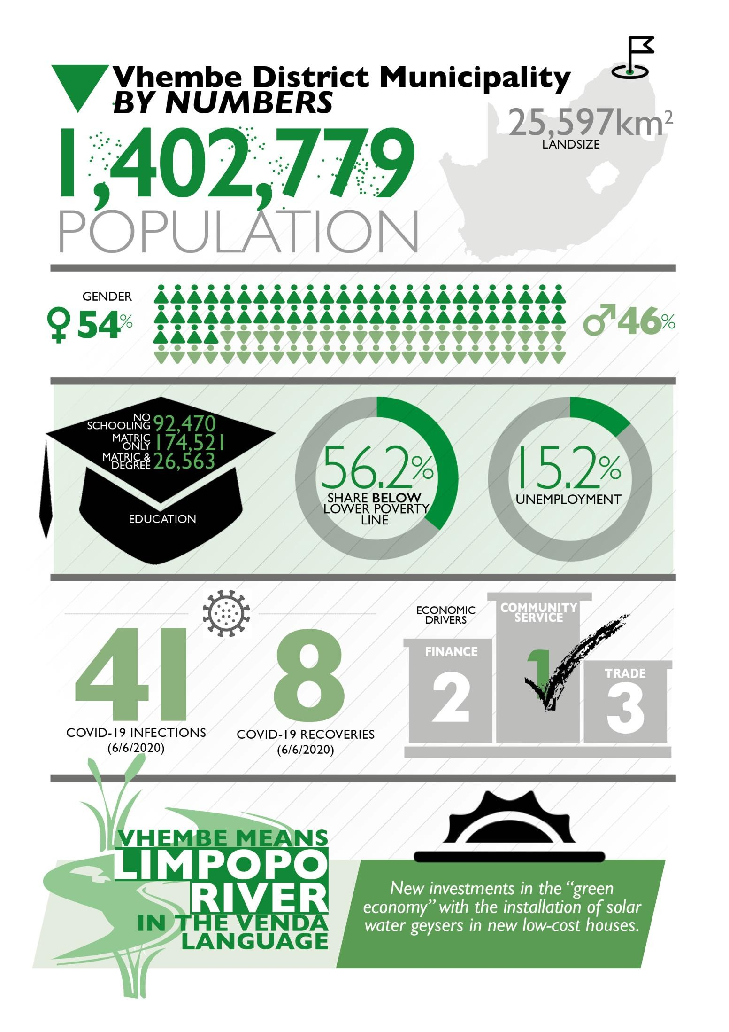


5
PROFILE: VHEMBE DISTRICT MUNICIPALITY

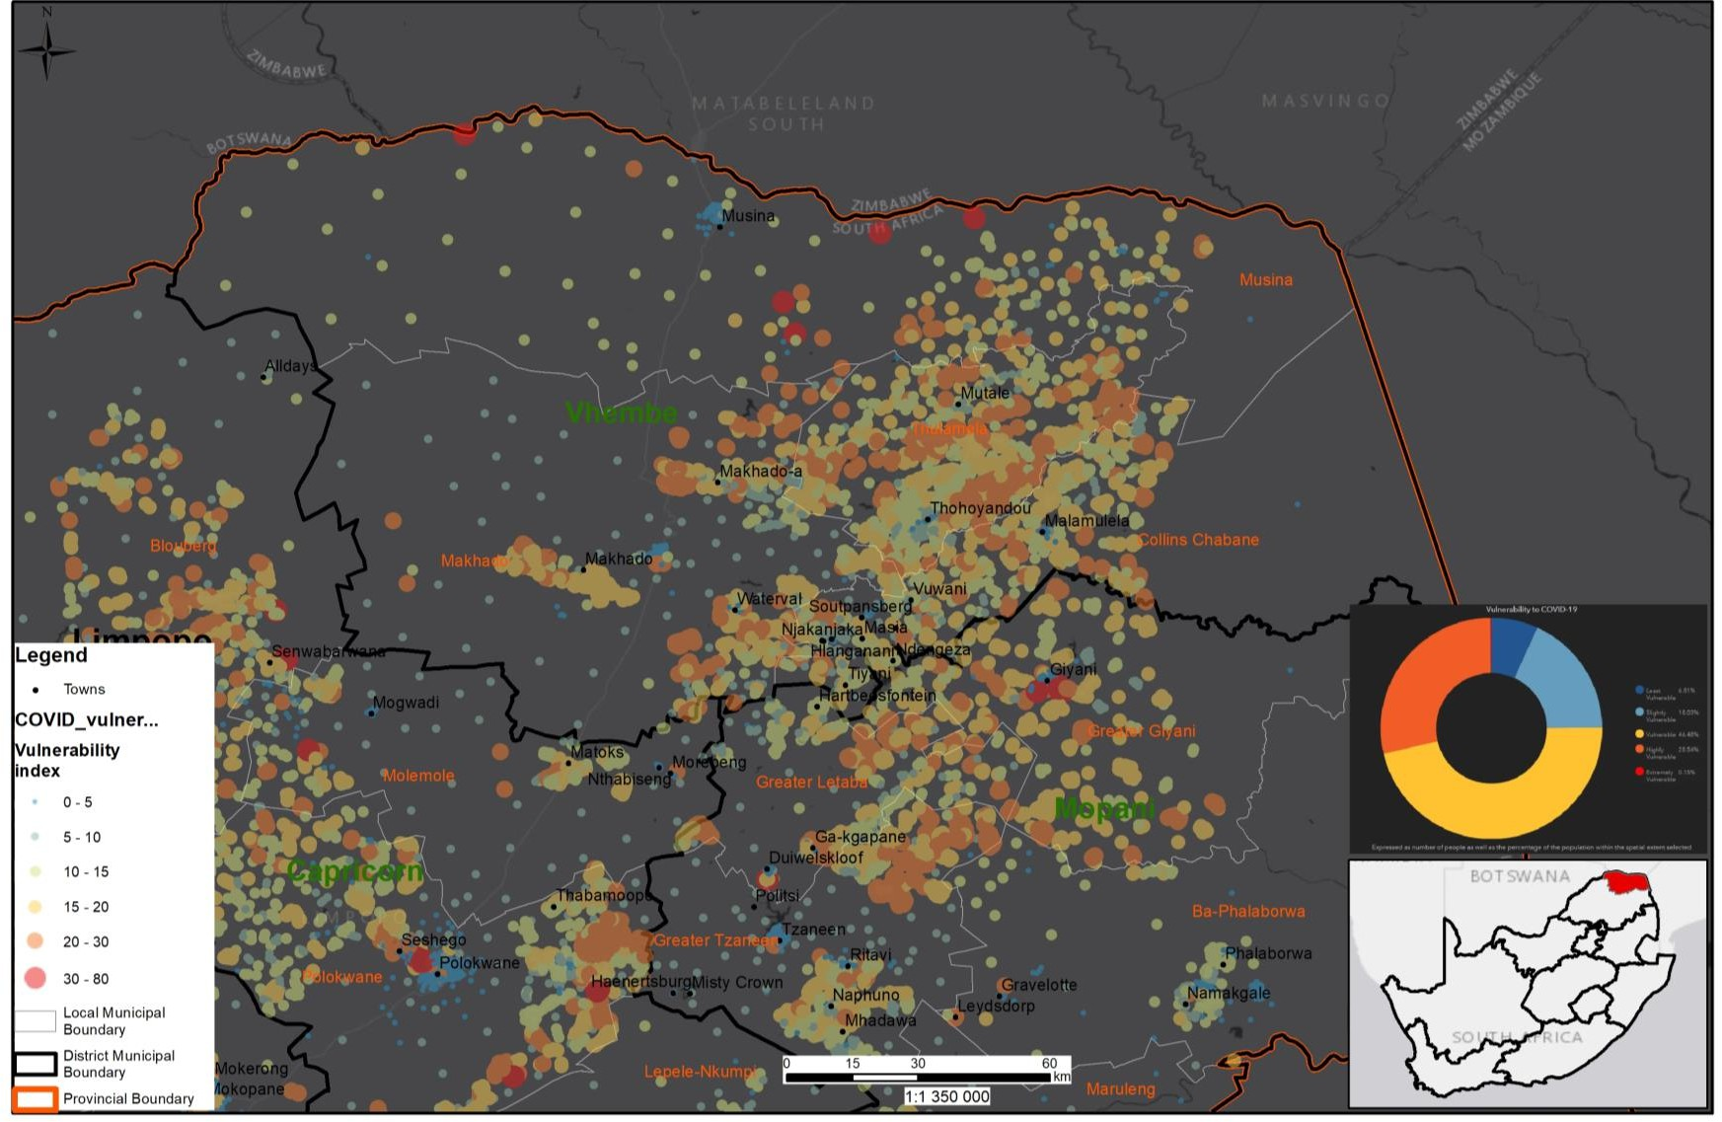

COVID-19 Vulnerability Index Vhembe
Source: CSIR/NCDM
`

Executive Summary

Vhembe District Municipality is a category C municipality and established in 2000 in terms of Local Government Municipal Structures Act No. 117 of 1998. The District is made-up of four (4) local municipalities, namely; Thulamela LM, Makhado LM, Musina LM and the recently established Collins Chabane LM.
The Vhembe District is located in the Northern part of Limpopo Province and shares boarders with Capricorn and Mopani districts in the eastern and western directions. The sharing of boarders extends to Zimbabwe in the north and Botswana in the north- west and Mozambique in the south-east through the Kruger National Park. The District has a land size of 25 597 square kilometres and has four (4) towns, namely; Makhado, Malamulele, Musina and Thohoyandou.
In terms of population size, in 2019 Vhembe District had a total of 1 402 779 people, with 416 728 residing in Makhado, 497 237 in Thulamela, 347 974 in Collins Chabane and 32 009 in Musina in 2016. Makhado is the most populated municipality in the district, while Musina LM is the least.
There are 7 470 child headed households in the district, with about one quarter of the figure in Limpopo and less than 10% in the country. About 51% of these households are headed by headed by women.

In relation to the heath wellbeing of the district, three (3) highest causes of death for children under the age of 5 are: Diarrhoea (21%), lower respiratory infections (13.5%) and pre-term birth complications (9. 2%). The top two causes of death for young women and men between the ages 15-24 are accidental threats to breathing at 14.2% and road injuries at 13.3%. In the age group 25 to 64, the top causes of death for males and females are TB, HIV/AIDS and lower respiratory infections.

Within Vhembe District Municipality, the number of people without any schooling decreased from 167 166 (2009) to 92 469 (2019), while in the same period the number of people within the 'matric only' category, increased from 75 567 to 174 521. The number of people with 'matric and a certificate/diploma' increased from 25 736 to 55 648 in the same period, while number of people with a 'matric and a Bachelor's' degree increasing from 2 669 to 26 563. Overall improvement in the level of education is visible with an increase in the number of people with 'matric' or higher education.
With regards to the economy, with a GDP of R 63.4 billion in 2018 (up from R 27.8 billion in 2008), the District contributed 17.71% to the Limpopo Province GDP of R 358 billion in 2018, increasing in the share of the Limpopo from 17.09% in 2008. The District

contributes 1.30% to the GDP of South Africa which had a total GDP of R 4.87 trillion in 2018.
In terms of economic sector performance, the mining sector reached its highest point of growth of 4.9% in 2010. The agricultural sector experienced the lowest growth during 2016 at -7.4%, while the mining sector reaching its lowest point of growth in 2009 at - 18.8%.
In 2019, the community services sector was the largest accounting for 33% of the total GVA of the district economy. The sector that contributes the second most to the GVA is finance sector at 18%, followed by the trade (18%) and trade (17%). The sectors that contribute the least to the economy are agriculture and manufacturing with a contribution of 3% each of the total GVA.

In 2018, the working age population in Vhembe was 850 000, increasing at an average annual rate of 1.01% since 2008. For the same period, the working age population for Limpopo Province increased at 1.03% annually, while that of South Africa increased at 1.65% annually. Out of the economically active population, the district has a total of 60 400 (16.1%) unemployed people.

In terms of employment, the number of formally employed people in Vhembe counted 202 000 in 2018, which is about 67.20% of total employment, while the number of people employed in the informal sector counted 98 800 or 32.80% of the total employment. Informal employment in Vhembe increased from 62 100 in 2008 to an estimated 98 800 in 2018.

Introduction

Location
The Vhembe District is located in the Northern part of Limpopo Province and shares boarders with Capricorn and Mopani districts in the eastern and western directions. The sharing of boarders extends to Zimbabwe in the north and Botswana in the north-west and Mozambique in the south-east through the Kruger National Park.
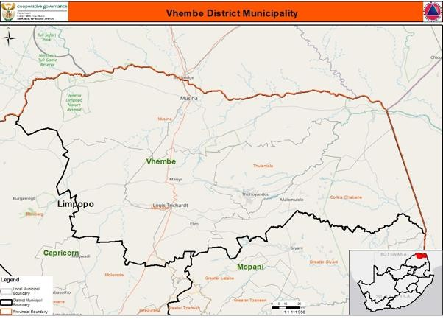

Historical Perspective
Vhembe means Limpopo River in the Venda language. Vhembe was originally settled by tribes of Khoisan peoples and later by the Venda people, migrating from what is now Matabeleland South in Zimbabwe and today constitute a majority of the population in this area.
Around 1820 onwards, the Tsonga people started to invade areas in the south eastern part of Venda and today live in their majority in these areas known as Malamulele and Hlanganani. Thereafter, the Boer colonialists arrived in Vhembe at around 1836. During the apartheid era, the Bantustan of Venda (declared

independent in 1979) was established in the eastern part of the Vhembe area, and was reintegrated into the country in 1994. The former Bantustan capital, Thohoyandou (named after a chief that had led the expansion of the Venda Empire in the 18th century) is the current capital of the Vhembe District Municipality.

Spatial Status
The District is made-up of four (4) local municipalities, namely; Thulamela LM, Makhado LM, Musina LM and the recently established Collins Chabane LM. The District has a land size of 25 597 square kilometres and has four (4) towns, namely; Makhado, Malamulele, Musina and Thohoyandou.
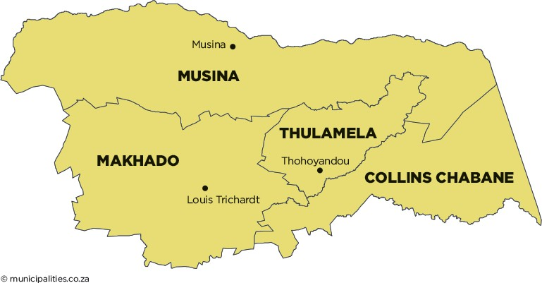

Social Development Profile

Key Social Demographics

Population

The Vhembe District has a total population of 1 402 779 people, increasing from 1 294 722 in 2011. According to Community Survey, in 2016 most of these people resided in Thulamela (497 237), followed by Makhado (416 728), Collins Chabane (347 974) and Musina (32 009). Thulamela LM is the most populated municipality in the district, while Musina LM is the least populous municipality in the district.

According to Global Insight, the district population grew by 0.9% in 2019 as compared to 0.6 in 2006. The population growth rate of the district is comparable to that of the province, but lower than the national figure of 1.5%.

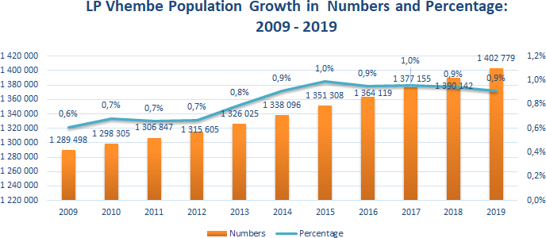
Source: Global Insight

Gender, Age and Race

54% or 757 501, of the population are females. The median age is 21 with 51% of the population being between 18 and 64. The highest segment are those who are below the age of 18 with 46% being under 19. These are significantly higher than the South Africa average. Males above these ages are significantly under represented relative to the South Africa average, assumingly because of the migrant labour system. Women between the ages 45 and 59, as well as above 75 are above the South African average.
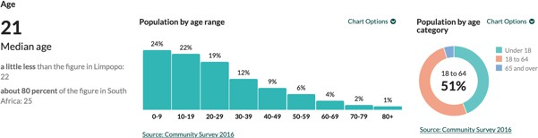


Population structure, Total, 2019
DC34 Vhembe vs. National
DC34 Vhembe
South Africa
Male
75
70-74
65-69
60-64
55-59
50-54
45-49
40-44
35-39
30-34
25-29
20-24
15-19
10-14
05-09
Female
8.0% 6.0% 4.0% 2.0% 0.0% 2.0% 4.0% 6.0% 8.0%
Source: IHS Markit Regional eXplorer version 1946
00-04
+

99% of the population are Black Africans and about 1% are whites, with very few coloureds (2 689) and Indians/Asians.

Households

There are 387 089 households in Vhembe as compared to 382 357 households 2016. about one-quarter of the provincial total (1 628 479) and about less than 10% (17 041 912) of the national figure. In 2016, a majority of the households (130 321) were in Thulamela LM, followed by Makhado LM (116 371), Collins Chabane LM (91 936) and Musina LM (43 730). About 2.8% of these households live in informal dwellings (shacks) and 78% live in a formal house.

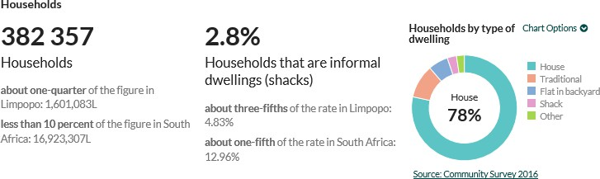

Household growth | Vhembe | Limpopo | National Total | Vhembe as % of Limpopo | Vhembe as % of National
2009 | 322 285 | 1 368 239 | 13 860 119 | 23,6% | 2,3%
2010 | 326 960 | 1 384 078 | 14 070 799 | 23,6% | 2,3%
2011 | 332 034 | 1 402 135 | 14 373 581 | 23,7% | 2,3%
2012 | 337 573 | 1 424 679 | 14 705 586 | 23,7% | 2,3%
2013 | 342 764 | 1 445 911 | 14 999 538 | 23,7% | 2,3%
2014 | 348 521 | 1 469 282 | 15 281 612 | 23,7% | 2,3%
2015 | 360 488 | 1 518 980 | 15 696 361 | 23,7% | 2,3%
2016 | 369 575 | 1 556 206 | 16 080 307 | 23,7% | 2,3%
2017 | 376 188 | 1 582 904 | 16 411 477 | 23,8% | 2,3%
2018 | 381 622 | 1 605 279 | 16 713 369 | 23,8% | 2,3%
2019 | 387 089 | 1 628 479 | 17 041 912 | 23,8% | 2,3%
Average Annual growth 2009-  2019 | 1,83% | 1,73% | 2,09%

Child Headed

There are 7 470 child headed households in the district which is about one quarter of the provincial total and less than 10% of the total number of child-headed households in the country. About 51% of these households are headed by women.
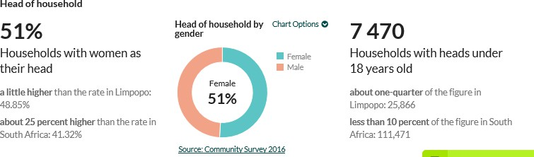

Women Headed Households

In terms of women headed households, the District has a total of 194 980 female headed households, as compared to 187 378 male headed households. Collins Thulamela has highest number of female headed households (65 728), followed by, Makhado (56 984), Collins Chabane (53 302) and Musina (18 966).

Health Profile
According to the Department of Health, the three highest causes of death for children under the age of 5 in Vhembe are: Diarrhoea (21%), lower respiratory infections (13.5%) and pre-term birth complications (9. 2%). The top two causes of death for young women and men between the ages 15-24 are accidental threats to breathing at

14.2% and road injuries at 13.3%. In the age group 25 to 64, the top causes of death for males and females are TB, HIV/AIDS and lower respiratory infections.
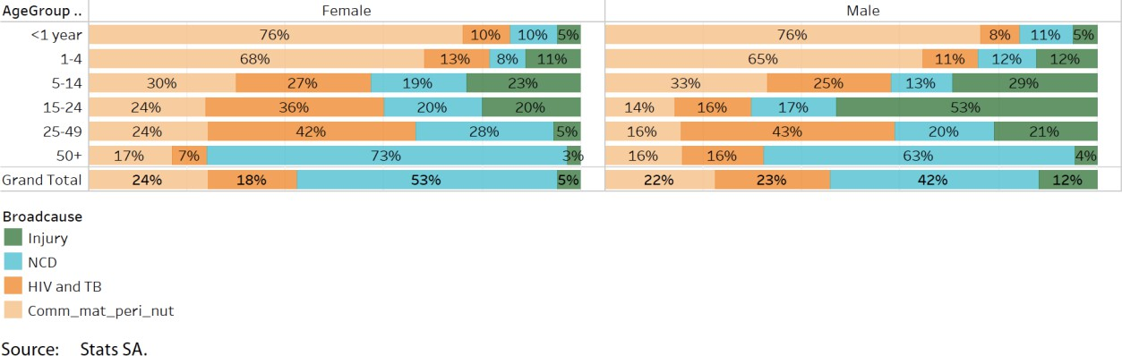

With regard to HIV, there are 64 372 people infected with HIV in Vhembe, this constitutes 19,5% and 1.53% of people infected with HIV in Limpopo and South Africa, respectively. The HIV/AIDS infected population represented 4.61% of the district total population in 2016. Amongst the HIV infected people, 2 451 are infected with TB. In addition, the top 3 causes of death affecting women in the childbearing age group are: indirect maternal (27.5%), other maternal (21.2%) and hypertension in pregnancy (20.2%)
In terms of facilities, the District has a total number of 116 clinics, 6 District hospitals and 1 regional Hospital. These facilities render comprehensive health care package to communities the District.

COVID-19

Number of cases

As of 06 June 2020, the Vhembe municipality has recorded 41 Covid- 19 positive cases with 3 active cases, 8 recoveries and 0 death.
The Council for Scientific and Industrial Research (CSIR) in collaboration with Albert Luthuli Centre for Responsible leadership have developed a set of COVID-19 Vulnerability Indicators using available data and knowledge. It identifies vulnerabilities present in communities and identifying areas in need of targeted coordinated interventions and early response. The purpose of the indicators is intended to support the early prevention/mitigation and preparedness phase of the disaster management cycle and informing disaster management decision making. It is not based on epidemiological modelling but a response to highlighting intervention areas due to underlying situation. The composition of the index follows two main factors, namely: transmission potential and health susceptibility.

Transmission potential areas identify areas that prevent social distancing to be practiced and where limitations of practicing good basic hygiene. The health susceptibility index denotes areas where large number of people are potential more susceptible to being adversely affected by COVID-10 due to factors such as age and underlying health conditions. The Vhembe vulnerability profile is presented below. The map shows low vulnerability areas (blue dotted areas) versus areas with higher vulnerability (red dotted areas)
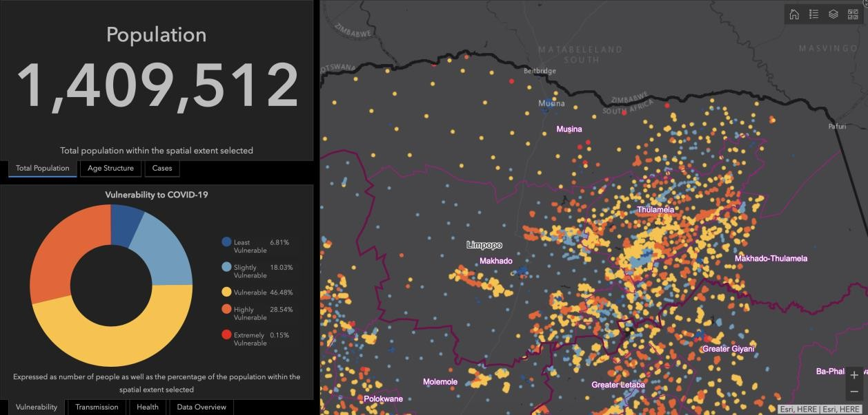

The area shows some extreme vulnerability alomng the border areas and Musina with some high vulenrability in Makhado and Thulamela which are densely populated areas. Area specific live GIS vunerability maps are available curtosy of CSIR at:
https://pta-gis-2-web1.csir.co.za/portal2/apps/opsdashboard/#/390a74fb10844c7a85396e60555a866d

Quarantine Facilities Available and Assessed

A total of 50 facilities assessed in the province of which 36 (18 Public and 18 Private) are readily available with 2084 beds. Three (03) facilities require minor repairs, while eleven (11) require major repairs.
A total of Four (04) quarantine facilities have been identified within Vhembe District Municipality to curb the spread of Corona virus, namely; Mphephu Resort (assessed pending approval), Mapungubwe National Park (not assessed), Makhumbani Waterfalls (not assessed) and Phidiphidi Waterfalls (not assessed).

Infrastructure (responding to COVID 19)

- Provision of Water and Sanitation

In Vhembe 5 Water Trucks (Tankers) and 152 Water (storage) tanks have been delivered.
- Reprioritization of the Budget

A total of 96 projects to the value of R 230,838,265 million have been reprioritized by municipalities (MIG funded) and 37 of these projects to a value of R70,200,000 are to be implemented in Vhembe District. A total 40 projects to the value of R 14 million are being implemented through funding by DBSA and MISA.

Social Support

The table below provides details of the food parcel distribution across the province and also shows that the total number of food parcels distributed in Vhembe as of 29 May 2020 is 10 433. When it comes to food parcels, total food parcels distributed in the province to date since the lockdown, increased to 91 384, this is the consolidated number of food parcels from DSD, SASSA and Other Donors.

“A total of Four (04) quarantine facilities have been identified within Vhembe District Municipality to curb the spread of Corona virus”

Poverty Dimensions

Distribution

In 2019, there were 788 514 people living in poverty, using the upper poverty line definition, across Vhembe District Municipality in comparison to 801 524 in 2009.

900,000
800,000
700,000
600,000
500,000
400,000
300,000
200,000
100,000
0

Number and Percentage of peole in poverty, Vhembe 2009- 2019

2009 2010 2011 2012 2013 2014 2015 2016 2017 2018 2019

70.0%
60.0%
50.0%
40.0%
30.0%
20.0%
10.0%
0.0%

People below the lower poverty line % below the lower poverty line

Inequality

In 2019, the Gini coefficient in Vhembe District Municipality was at 0.57, which represents a marginal increase from 2009 to 2019. As reflected in the figure below, the District has the lowest when compared to other districts in the province.

Inequality at District level
0.62
0.61
0.60
0.59
0.58
0.57
0.56
0.55
0.54
0.53
0.52
Mopani Vhembe Capricorn Waterberg Sekhukhune
2009 2013 2016 2019

Employed/Unemployed

The number of formally employed people in Vhembe counted 202 000 in 2018, which is about 67.20% of total employment in the district, while the number of people employed in the informal sector counted 98 800 or 32.80% of the total employment. Informal employment in Vhembe increased from 62 100 in 2008 to an estimated 98 800 in 2018.

80,000
70,000
60,000
50,000
40,000
30,000
20,000
10,000
0

Formal and informal employment by sector Vhembe, 2018


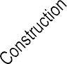

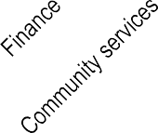

Formal employment Informal employment
Source: IHS Markit Regional eXplorer version 1803

Crime

The prevalent crimes in the district are as follows: Murder, Attempted murder Arson, Driving under the influence of liquor and Robbery with aggravating circumstances, Car hijacking, Robbery at residential premises and robbery at non-Residential areas. The latter two crimes are more prevalent in Thulamela and Makhado.

About 2.79% of the people in the Districts experience housebreaking than any type of crime followed by 1.18% of home robbery. Out of 2.79% of housebreaking Thulamela contribute 1.23% which is the highest percentage compared to other local municipalities as indicated in table below. The crime rate is very low because most crimes are below 1% except house breaking and home robbery standing at 1% and 2.79%, respectively.

Table: Experience of crime for person weight per percentage (%)
 | Murder | Home robbery | Housebrea king | Robbery | Theft of livestock, poultry and other animals | Theft of motor vehicles/ motorcycle | Other crimes
Vhembe | 0.08 | 1.18 | 2.79 | 0.84 | 0.18 | 0.11 | 0.31
Musina | 0.03 | 0.21 | 0.49 | 0.15 | 0.08 | 0.02 | 0.05
Thulamela | 0.03 | 0.53 | 1.23 | 0.33 | 0.04 | 0.06 | 0.06
Makhado | 0.01 | 0.25 | 0.65 | 0.20 | 0.02 | 0.01 | 0.10
Collins Chabane | 0.00 | 0.19 | 0.39 | 0.17 | 0.03 | 0.01 | 0.10

Education and skills profile
Within Vhembe District Municipality, the number of people without any schooling decreased from 167 166 (2009) to 92 469 (2019), while in the same period the number of people within the 'matric only' category, increased from 75 567 to 174 521. The number of people with 'matric and a certificate/diploma' increased from 25 736 to 55 648 in the same period, while number of people with a 'matric and a Bachelor's' degree increasing from 2 669 to 26 563. Overall improvement in the level of education is visible with an increase in the number of people with 'matric' or higher education.

“The number of formally employed people in Vhembe counted 202 000 in 2018, which is about 67.20% of total employment
IN THE DISTRICT”
Progress in Education DC34 Vhembe, Total
100%
90%
80%
70%
Matric & Postgrad degree
Matric & Bachelors degree
Matric & certificate / diploma
Matric only
60%
50%
Certificate / diploma without matric Grade 10-11
40%
Grade 7-9
30%
Grade 3-6
20%
Grade 0-2
10%
No schooling
0%
1997 1999 2001 2003 2005 2007 2009 2011 2013 2015 2017 2019
Source: IHS Markit Regional eXplorer version 1946

According to the District Integrated Development Plan (IDP), there are 27 circuit offices and 938 public schools (many of these schools are concentrated in Thulamela and Makhado). In addition, there are 132 Adult Basic Education & Training (ABET) centres 1 University, 9 TVET colleges (number inclusive of satellite campuses) and 413 Early Childhood Development centres.

Drivers Of Economy

Structure of the economy

With a GDP of R 63.4 billion in 2018 (up from R 27.8 billion in 2008), Vhembe District contributed 17.71% to the Limpopo Province GDP of R 358 billion in 2018, increasing in the share of the Limpopo from 17.09% in 2008. The District contributed 1.30% to the GDP of South Africa which had a total GDP of R 4.87 trillion in 2018.

In 2019, the community services sector was the largest accounting for 33% of the total GVA of the district economy. The sector that contributes the second most to the GVA is finance sector at 18%, followed by the trade (18%) and trade (17%). The sectors that contribute the least to the economy are agriculture and manufacturing with a contribution of 3% each of the total GVA.
GVA-R Sectoral composition
DC34 Vhembe, 2019
9 Community services
33%
1 Agriculture
3%
8 Finance
18%
2 Mining
10%
7 Transport
6%
6 Trade
17%
- Manufacturing
3%
- Electricity
6%
- Construction
4%
Source: IHS Markit Regional eXplorer version 1946

Primary Sector
The primary sector in the district consists of two broad economic sectors, namely; mining and the agriculture. The chart below depicts the average growth rate in the GVA for both sectors in Vhembe from 2008 to 2018.

25%
20%
15%
10%
5%
0%
-5%
-10%
-15%
-20%
-25%

Gross value added (GVA) by primary sector
Vhembe, 2008-2018
2008
2009
2010
2011
2012
2013
2014
2015
2016
2017
2018

Agriculture Mining

Source: IHS Markit Regional eXplorer version 1803

Between 2008 and 2018, agricultural sector experienced the highest positive growth with an average growth rate of 20.8%, while the mining sector reached its highest point of growth of 4.9% in 2010. The agricultural sector experienced the lowest growth for the period during 2016 at -7.4%, while the mining sector reaching its lowest point of growth in 2009 at -18.8%.

Secondary Sector
The secondary sector in Vhembe consists of three broad economic sectors, namely; manufacturing, electricity and construction. The chart below shows average growth rates in the GVA for these sectors in Vhembe from 2008 to 2018.

Gross value added (GVA) by secondary sector
15% Vhembe, 2008-2018

10%

2008 2009 2010 2011 2012 2013 2014 2015 2016 2017 2018

5%

0%

-5%

-10%

-15%

Manufacturing Electricity Construction

Source: IHS Markit Regional eXplorer version 1803

Between 2008 and 2018, the manufacturing sector experienced the highest positive growth in 2010 with a growth rate of 5.4%. The construction sector reached its highest growth in 2008 at 13.7%. The manufacturing sector experienced its lowest growth in 2017 dipping to -13.1%, while construction sector reached its lowest point of growth in 2017 at -0.4% growth rate. The electricity sector experienced the highest growth in 2010 at 5.3%, while it recorded the lowest growth of -5.6% in 2009.

“In 2018, the trade sector recorded the highest number of jobs created in the informal economy, with about 40 500 people employed in the sector”

Tertiary Sector
The tertiary sector in the district consists of four broad economic sectors, namely; trade, transport, finance and community services. The chart below represents the average growth rates in the GVA for these sectors in Vhembe from 2008 to 2018.

Gross value added (GVA) by tertiary sector
Vhembe, 2008-2018
8%

6%

2008 2009 2010 2011 2012 2013 2014 2015 2016 2017 2018

4%

2%

0%

-2%

-4%

Trade Transport Finance Community services

Source: IHS Markit Regional eXplorer version 1803

The trade sector experienced the highest positive growth in 2011 with a growth rate of 3.9%. The transport sector reached its highest point of growth in 2008 at 6.2%. The

finance sector experienced the highest growth rate in 2018 when it grew by 6.0% and recorded the lowest growth rate in 2016 at -0.2%. The Trade sector had the lowest growth rate in 2009 at -2.3%. The community services sector, which largely consists of government, experienced its highest positive growth in 2011 with 5.8% and the lowest growth rate in 2009 with -0.3%.

Informal Trading

Informal Economy

In 2018, the trade sector recorded the highest number of jobs created in the informal economy, with about 40 500 people employed in the sector. This is to be expected as the barriers to enter the trade sector in terms of capital and skills required are less as compared the other sectors. The finance sector has the lowest informal employment with 5 200 and only contributes 5.27% to total informal employment

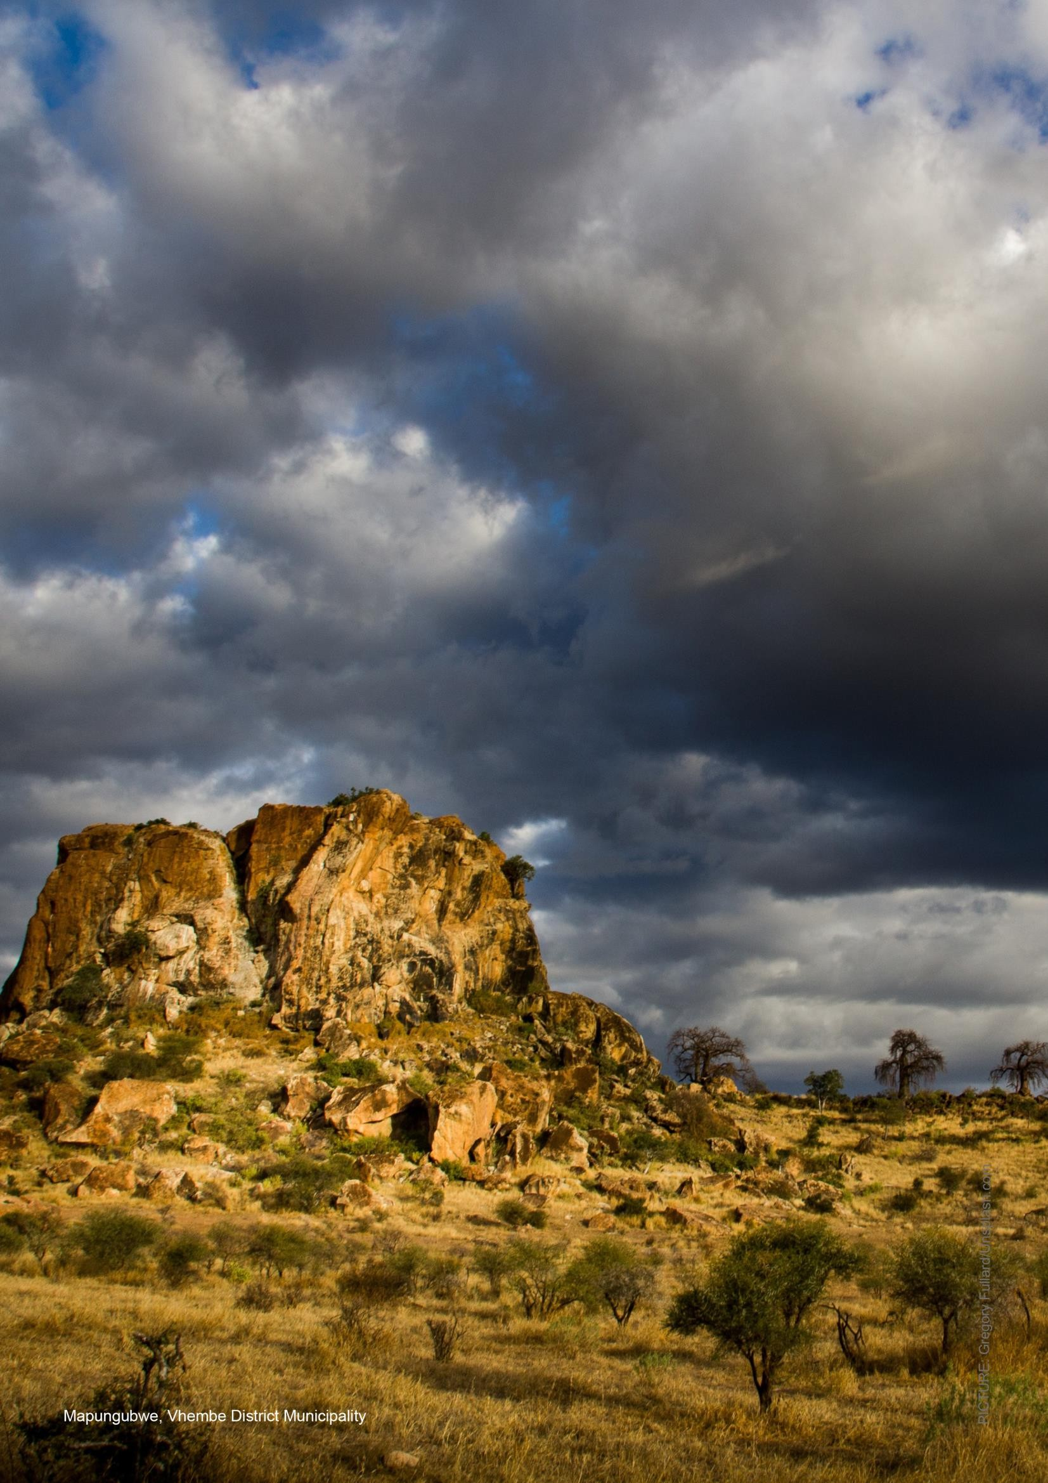
PROFILE: VHEMBE DISTRICT MUNICIPALITY
23

Servive Delivery

Water and sanitation

Water

Almost 9% of households use underground water from boreholes and 91% surface water in the district. About 40% of households have water inside the yard, which is the highest level of water service standard. About 6.36% of households are using water from rain-water tanks, river, springs, and wells.
In terms of access to safe and healthy drinking water in the district, about 4.05% households in Thulamela LM have no access to water, followed by in Makhado LM at 1.38%, Musina LM at 55% and Collins Chabane LM at 0.40%. The highest number of households without access to safe and health drinking water is in Thulamela LM.
A majority of household, approximately 78.1% are supplied with water from municipality, with 33% of the households with piped water inside the yard.
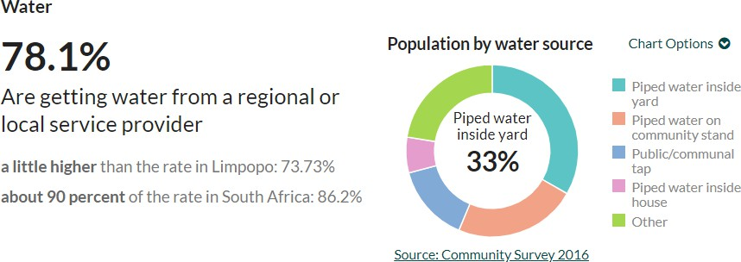

There are 39 water supply schemes in the Vhembe. Challenges in the water supply schemes are experienced due to the limited funding of the district. There are also challenges relating to the construction of some of the newer schemes, with contractors struggling to finish projects on time, which leads to a backlog of infrastructure upgrades and extensions.

Another issue that the municipality is facing is illegal connections and the lack of water meters. Due to the lack of staff and funding within the municipality upgrades and extensions of water schemes are not executed on time. This results in many of illegal connections to reservoirs and/or standpipes. In this regard, the district aims to provide every household with a yard connection by the end of 2020 which seems impossible to do since the municipality only has limited staff and financing available for this purpose. A great amount of the water supplied to the community is unaccounted for. This is due to problems with metering and billing.

Sanitation

The table below indicates that 2.74% of the household in the district use flush toilet connected to a septic tank or conservancy tank, 15.97% is a public sewerage system and 5.96% none (without toilet). About 13% of the households in urban areas have flush toilets connected to sewerage system compared to 2% in traditional. This shows that there are still households in urban areas without flush toilets in the district.

Table: The main type of toilet facility used by households
 | LIM341  Musina | LIM343 :  Thulamela | LIM344 :  Makhado | LIM345 :  Collins Chabane | DC34:  Vhembe
Flush toilet connected to a  public sewerage system | 23849  (6.24%) | 15315  (4.01%) | 14825  (3.88%) | 7083  (185%) | 61071  (15.97%)
Flush toilet connected to a septic tank or conservancy  tank | 1361  (0.36%) | 4877  (1.28%) | 3196  (0.84%) | 1041  (0.27%) | 10476  (2.74%)
Chemical toilet | - | 643  (0.17%) | 1449  (0.38%) | 2233  (0.58%) | 4325  (1.13%)
Pit latrine/toilet with  ventilation pipe | 12424  (3.25%) | 41783  (10.93%) | 38626  (10.10%) | 31796  (8.32%) | 124628  (32.59%)
Pit latrine/toilet without  ventilation pipe | 2895  (0.76%) | 59648  (15.60%) | 52577  (13.75%) | 35042  (9.16%) | 150162  (39.27%)
Ecological toilet (e.g. urine  diversion; enviroloo; etc.) | 314  (0.08%) | 153  (0.04%) | 49  (0.01%) | 246  (0.06%) | 763  (0.20%)
Bucket toilet (collected by  municipality) - Other | 789  (0.21%) | 2682  (0.70%) | 1415  (0.37%) | 3270  (0.86%) | 8155  (2.13%)
None | 2099  (0.55%) | 5219  (1.36%) | 4234  (1.11%) | 11225  (2.94%) | 22778  (5.96%)
Household Total | 43730 | 130320 | 116371 | 91936 | 382357
Source: StatsSA, Community Survey 2016

Vhembe district municipality had VIP toilets backlog of 117 143 in 2018/19 financial year and managed to build 1000.

Human Settlements
According to Community Survey 2016, Vhembe district municipality has 382 358 households of which 194 980 are female headed household compare to 187 378 male. The table below shows that 13.22% household head in the district live in RDP or government subsidized dwelling. Collins Chabane has higher percentage (4.36%) of household living in RDP or government subsidized dwelling compared to other local municipalities.

Main dwelling; RDP or government subsidized dwelling by geography hierarchy for household weight
 | Musina | Thulamela | Makhado | Collins  Chabane | VDM
Yes | 10132 (2.65%) | 12608 (3.30%) | 11143 (2.91%) | 16658 (4.36%) | 50541 (13.22%)
No | 32384 (8.47%) | 117449 (30.72%) | 104982 (27.46%) | 75180 (19.66%) | 329995 (86.31%)
Do not  know - Unspecified | 1214 (0.32%) | 263 9 (0.07%) | 246 (0.06%) | 99 (0.03%) | 1822 (0.48%)
Grand Total | 43730 | 130320 | 116371 | 91936 | 382357
Source: Stats SA, Community Survey 2016

The majority (79.98%) of people in the district live in Formal dwelling/house or brick/concrete block structure.

Waste Management
In terms of waste removal, Musina LM collects 13 000 tons in urban and rural areas per month. Collins Chabane LM collects 576 tons in town per month. Makhado LM collects 9127 cubic per months, while Thulamela LM collects 5761 cubic meters in town and rural per week respectively. When it comes to waste collection in rural areas the removal is done by local authority/ private company/ community members at least once a week. The table below shows the removal of refuse per household - about 65 684 households use the services of authority/private company/community for refuse collection. The collection by the services of authority/private company/community is done at least once a week in some areas and less often than once a week in other areas. A total population of 282 816 uses different types of the refuse removal e.g. Communal container/central collection point and Dump or leave rubbish anywhere (no rubbish disposal).

Refuse removal per Household
 | Musina | Thulamela | Makhado | Collins Chabane | Vhembe
Removed by local authority/private company/community members at least 1/W | 24575 | 22911 | 11816 | 3836 | 63138
Removed by local authority/private  company/ community members less often than 1/W | 450 | 945 | 431 | 120 | 1946
Communal refuse dump | 3026 | 2181 | 4322 | 1394 | 10923
Communal container/central collection point | 400 | 160 | 1406 | 80 | 2046
Own refuse dump | 13118 | 97586 | 93068 | 79045 | 282816
Dump rubbish anywhere (no rubbish disposal) | 1733 | 6076 | 4318 | 6343 | 18470
Other | 428 | 460 | 1012 | 1117 | 3017
Total | 43730 | 130319 | 116373 | 91935 | 382356

Source: StatsSA, Community Survey 2016

Roads and transport
The total length of Vhembe district surfaced road is 1368.44 km, however there is still 2482.39 kilometres backlog (gravel road) in the district.
There are four (4) formal bus ranks and twenty-two (22) formal taxi ranks and two
(2) Intermodal facilities in the District. The main problems are regular break down of machines and equipment, shortage of machines and ageing personnel are the routine maintenance major challenges in the district.

Electricity
In terms of electricity, 93.74% of households in the district have access to electricity and 3% has no access to electricity as reflected in the figure below. This demonstrates that Eskom, Musina and Makhado local municipalities as electricity providers are doing well in terms ensuring that everyone has access to electricity. Collins Chabane local municipality has highest number of households without access to electricity at 1.23% compared to other municipalities.
The electricity backlog in the district is 3% household which is a combined percentage variable of no access to electricity and generator.
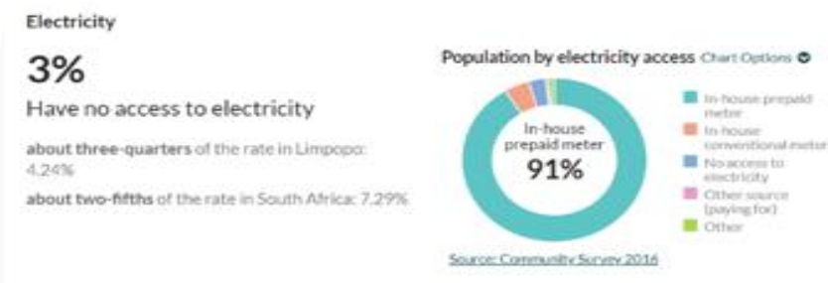

“The total length of Vhembe district surfaced road is 1368.44 km, however there is still 2482.39 kilometres backlog
(GRAVEL ROAD) IN THE DISTRICT.”

Governace and Management

Municipality Performance

The municipality’s total budget amounts to R1,7 billion of which an amount of R1,2 billion has been allocated to operating revenue and an amount R0.573 billion was allocated to capital transfers. Total revenue has increased by R116 million or 7% for the 2019/20 budget year when compared to the 2018/19 Adjustment Budget. For the two outer years, total revenue increased by 7% and 8% respectively.
Equitable Share transfer increased by 7% when compared to the 2018/19 Adjustment budget and the outer years increased by 8% respectively. MIG transfer increased by 2% when compared to the 2018/19 Adjustment budget and the outer years increased by 6% and 8% respectively.
Water sales increased by 5% compared to the 2018/19 Adjustment budget and the two outer years increased by 5%. The increase is mainly due to anticipated revenues to be collected on water sales taking into account the annual inflation rate and GDP growth rate over the 2019 MTREF period.

Municipality is complying with Monthly, Quarterly and Half-yearly reports in terms of the MFMA. Financial Statements were submitted to AG in time and the outcomes are indicated below. Vhembe District Municipality received Disclaimer Audit Opinion Report since 2015/16 financial year; on the other hand Thulamela local municipality has maintained Unqualified Audit Opinion since 2014/15 financial year.

Municipality Capacity
The table below shows that the district has 1950 posts of which 1641 filled and 309 are vacant. Majority of employees are adults according to district age analysis, 1259 employees are in the ages between 41 and 60, while 198 employees are in the ages between 22 and 40 years.

 | Number of  posts | Filled  Positions | Vacant  positions | % of positions  filled
Musina Local Municipality | 724 | 384 | 340 | 53.03%
Thulamela Local Municipality | 647 | 589 | 58 | 91.0%
Collins Chabane  Local Municipality | 339 | 122 | 217 | 35.9%
Makhado Local Municipality | 969 | 845 | 124 | 87.2%
Vhembe District Municipality | 1950 | 1641 | 309 | 84.1%

According to an assessment conducted by the Municipal Demarcation Board in 2018, there are 25 Engineers and engineering technologists, 24 planners and planning technicians, 1 qualified accountant and 58 environmental officers across the municipalities within the district as depicted in the table below.
Number of filled posts per Discipline
 | Vhembe DM | Musina | Thulamela | Collins  Chabane | Makhado
Qualified engineers and  engineering technologists | 1 | 1 | 6 | 5 | 12
Qualified planners and  planning technicians | 1 | 5 | 7 | 3 | 8
Qualified accountants | 1 | 0 | 0 | 0 | 0
Environmental officers | 21 | 36 | 0 | 0 | 1

Traditional Affairs Governance
There is one Vhembe Local House of Traditional Leaders functional at district level, whilst within local municipalities there are 43 Traditional Councils (TCs) led by Senior Traditional Leaders across the district. The main challenges in the districts are, amongst others, strengthening cooperative governance between municipalities and traditional leadership institutions as prescribed by legislation towards the development of local communities and re-constitution of traditional councils.

There is one Vhembe Local House of Traditional Leaders functional at district level, whilst within local municipalities there are 43 Traditional Councils (TCs) led by Senior Traditional Leaders across the district.

Projects to Diversify and Grow People and the Economy

Social Development Projects
The table below shows the social development projects within the district.

Department: Department of Arts and culture CAPITAL PROJECTS
 | MUNICIPALITY |  | COORDINATES (GIS) |  | BUDGET
Project Description | Local Municipality | District Municipality | Latitude | Longitude | Project Costs  (2020/21) | Actual Expenditure  2020/25
Constructio n of library |  | Vhembe | Site identification ongoing | Site identification ongoing | R19,000,000 | R0,0
Constructio n of a library |  | Vhembe | To be updated | To be updated | R19,000,000 | R 0,00

Project Name

1.
Mulamula District Library
2.
Vleifontein Library
Name of the Department: Department of Transport and Community Safety (Community Safety)
Other Projects Project
 | Municipality |  | Coordinates |  | Budget
Project description | Local Mun | District Mun | Latitude | Longitude | Total Project Cost | Actual  Expenditure 2019/20
SAPS  supervised patrols by identified youth |  | Vhembe | 31,548767  9 | 28,6719052 | R400 000 for identified Clusters in the District (Overall provincial  cost R 2 million) | R 0,00  (Project started in September 2019)
Cleaning and clearing of Contact Crime Hotspots |  | Vhembe | 31,548767  9 | 28,6719052 | R640 000  police stations in District  (Total budget for provincial cost R 4.5  million) | R 120 000  (estimate)
Financial model for supporting CPF/CSFs  per Limpopo: Policy on Community Safety  Forum and Board |  | Vhembe | 31,548767  9 | 28,6719052 | R4 500 000  for the whole of Limpopo Province (estimates for Vhembe would be R800 000. | R2 000 000  (estimate) for the whole province. Estimate for Vhembe would be R357 142.

Name

EPWP
Crime Prevention Through Environme ntal Design (CPTED)

Young Civilians on Patrol (YCOP)

Communit y Safety and Community Policing for a Support

Department of Education

Capital Projects Project
 | Municipality |  | Coordinates |  | Budget
Project description | Local Mun | District Mun | Latitude | Longitude | Total Project Cost | Actual  Expenditure 2019/20
Construct 4 additional girls’ toilets.  Refurbish borehole and Water reticulation network.  Provide 2 x 10 KL tanks on 4m high Tank Stands.  Refurbish 19 existing Waterborne toilets. Disludge existing Sceptic tank | Vhembe | Vhembe | 3.308623° | 30.639566° | R1 500  000,00 | 0,00
Refurbish 32 enviroloos. Demolish 25 pit toilets. | Vhembe | Vhembe | -23,015004 | 27.935005° | 1 096 000,00 | 0,00

Name

Akani Secondary

Gidjana Secondary

Spatial Development
The Vhembe District Municipality Spatial Development Framework identifies the following key development priority areas as depicted in the figure below.

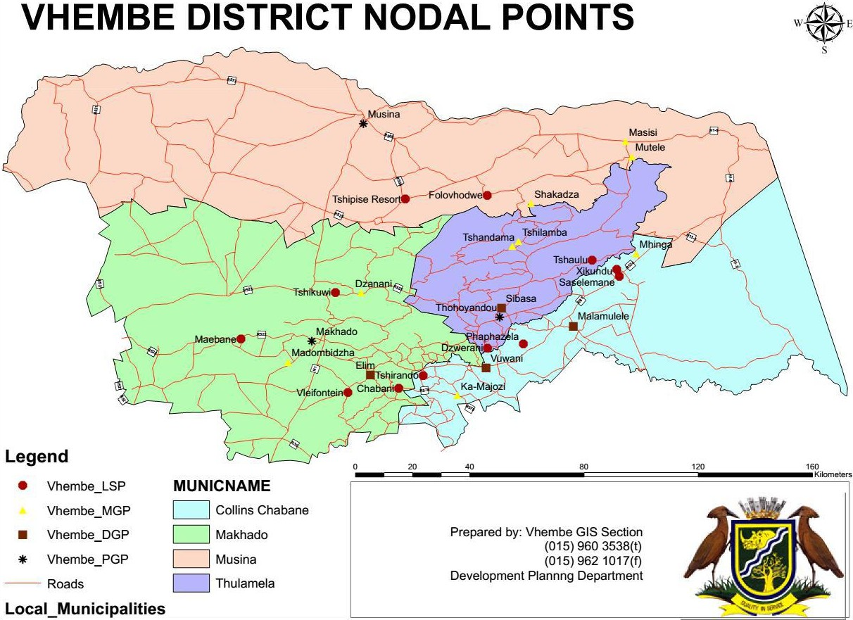

Infrastructure Projects

Top 3 Infrastructure Projects
Project Name | Source of Funding | Local Municipality | Ward Number/Village | Target/ Beneficiaries | Budget
 |  |  |  |  | 2019/20 | 2020/21 | 2021/22
Vuwani to Vyeboom and construction of reservoir | MIG | Collins Chabane | Manavhela, Mudziafera, Nditwani, Tshilaphala, Tshino north and south, tshitungulwane, Tshivhulana, Vuu, Vuwani,  and vuwani ext 2 | 12 204 | R  54 233  669.15 | R  76 909 1  32.60 | R  77 393  353.36
Jerome Command Reservoir (3,5ML)  Subsystem | MIG | Collins Chabane | Basani, Phaweni, Roadhuis, Nyavhani, Tshikonelo, Xigalo, Dlamani,  Khangela | 12 204 | R  17 588  741.34 | - | -
Makhado West Bulk Water Supply-  Stage 3 | MIG | Makhado | Majosi sub- scheme, Tshitale South | 12 204 | R  46 700  000.00 | R  16 043 8  23.13 | -

  - Economic Projects
The Industrial Development Corporation (IDC) has committed R25-billion to new investments in South Africa's "green economy" over the next five year and started with the installation of solar water geysers in new low-cost houses. The district together with UNIVEN/Gondal/CLGH and Eskom are engaged in supporting the Bio energy projects and manufacturing of Solar power in the district.
Musina (Musina and Nancefield) and Makhado Local Municipality have been identified as a provincial growth point and declared as a Special Economic Zone (1st order settlement) due to their relative high level of economic activity and rendering of services to local and surrounding communities.

Environmental Forecast
The Vhembe District municipality has Integrated Waste Management Plan and Environmental management plan which are in line with National Environmental Management Act, 2008 (NEMA) and other environmental legislations such as Environmental Conservation Act,73 of 1989, Air Quality Act, 39 of 2004, Heritage Resources Act, 25 of 1995. District has a wealth of natural resources which unfortunately is faced with a variety of challenges, from resources over-exploitation to land degradation. Better life for all the residents of the Vhembe District can be achieved through sustainable development, which ensures efficient balance between social, economic and environmental needs. Deforestation, erosion, invasion of alien species, rodents, insects and pests plague, drought, pollution, destabilisation of wetlands, veldfires, poaching and floods are main environmental challenges here.

Climate Change

Vhembe District Municipality acknowledges that climate change poses a threat to the environment, its residents, and future development. Actions are required to reduce carbon emissions (mitigation), and prepare for the changes that are projected to take place (adaptation) in the District. Vhembe District Municipality has therefore prioritised the development of a Climate Change Vulnerability Assessment and Climate Change Response Plan. The plan was developed through the Local Government Climate Change Support (LGCCS) program, with support from the Department of Environmental Affairs (DEA) and the Deutsche Gesellschaft for International (GIZ). The plan is currently on its final phase of development.

“Vhembe District Municipality has therefore prioritised the development of a Climate

Change Vulnerability Assessment and Climate Change Response Plan.”

Key Recommendations

Prioritise Integrated Development Plan
In view of the fact that Musina and Makhado have been identified as a provincial growth point and declared as a Special Economic Zone (1st order settlement) due to their relative high level of economic activity and rendering of services to local and surrounding communities, there is a need start developing long term plans to guide future development in the region. In this regard, the impeding ONE PLAN for the district should be anchored by programmes and plans that drive the implementation of the SEZ.

Investor and Sponsorship opportunities
Table 1: Private sector
Project Description | Municipality | Location | Development Cost
Makhado Crossing Regional Mall |  | Makhado | R600 million
Mphephu Plaza | Makhado | Siloam | R150 million
Nkuzana Development Precinct:  - Industries  - Private/Public Sector Offices  - Intermodal Facility  - Shopping Centre  - Value Retail Centre  - Hotel with Conference Facilities  - Business Sites  - 399 Residential Sites  - Public Open Space | Collins Chabane | Nkuzana | R1.4 Billion
Source: Masingita Group of Companies, 2019

Table 2: Private sector
Project Description | Municipality | Location | Development Cost
Siloam Shopping Center | Makhado | Siloam | R300m
Nandoni Golf Estate:  - Golf course  - Club house | Collins Chabani | Mulenzhe | R1bn

- Hotel
- Private School
- Shopping center
- Garage
- Water park and Happy Island
Thavhani phase 2:  - Motor city  - Private Hospital  - Hotel | Thulamela | Thohoyandou | R2bn
Source: Thavhani Property Investment, 2019
Special Economic Zone  (SEZ) | Makhado/Musina | Arntonvilla | R110m
Special Economic Zone  (SEZ) |  | Bokmakierie | R1bn





36

PROFILE: VHEMBE DISTRICT MUNICIPALITY

