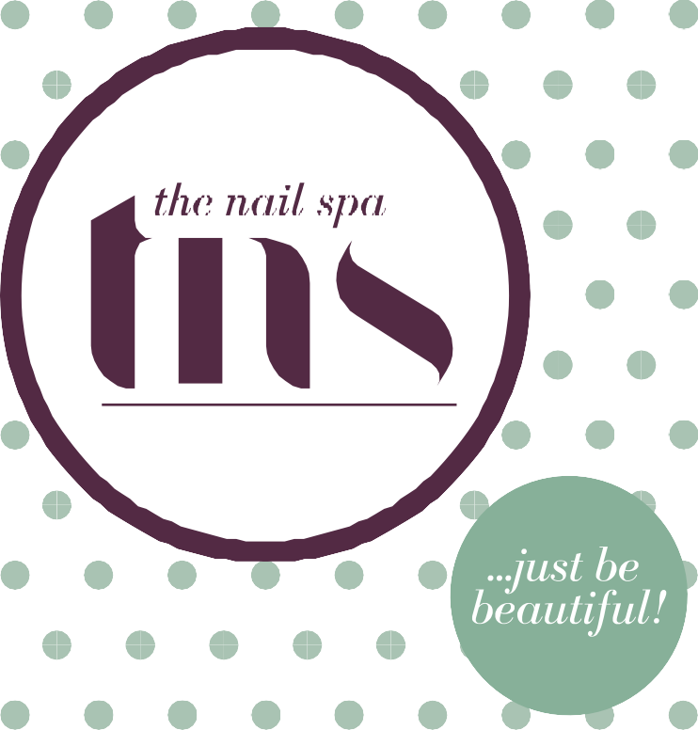

Corporate Profile

A quest for quintessential beauty
Welcome to TNS, a place where women can

…just be beautiful!

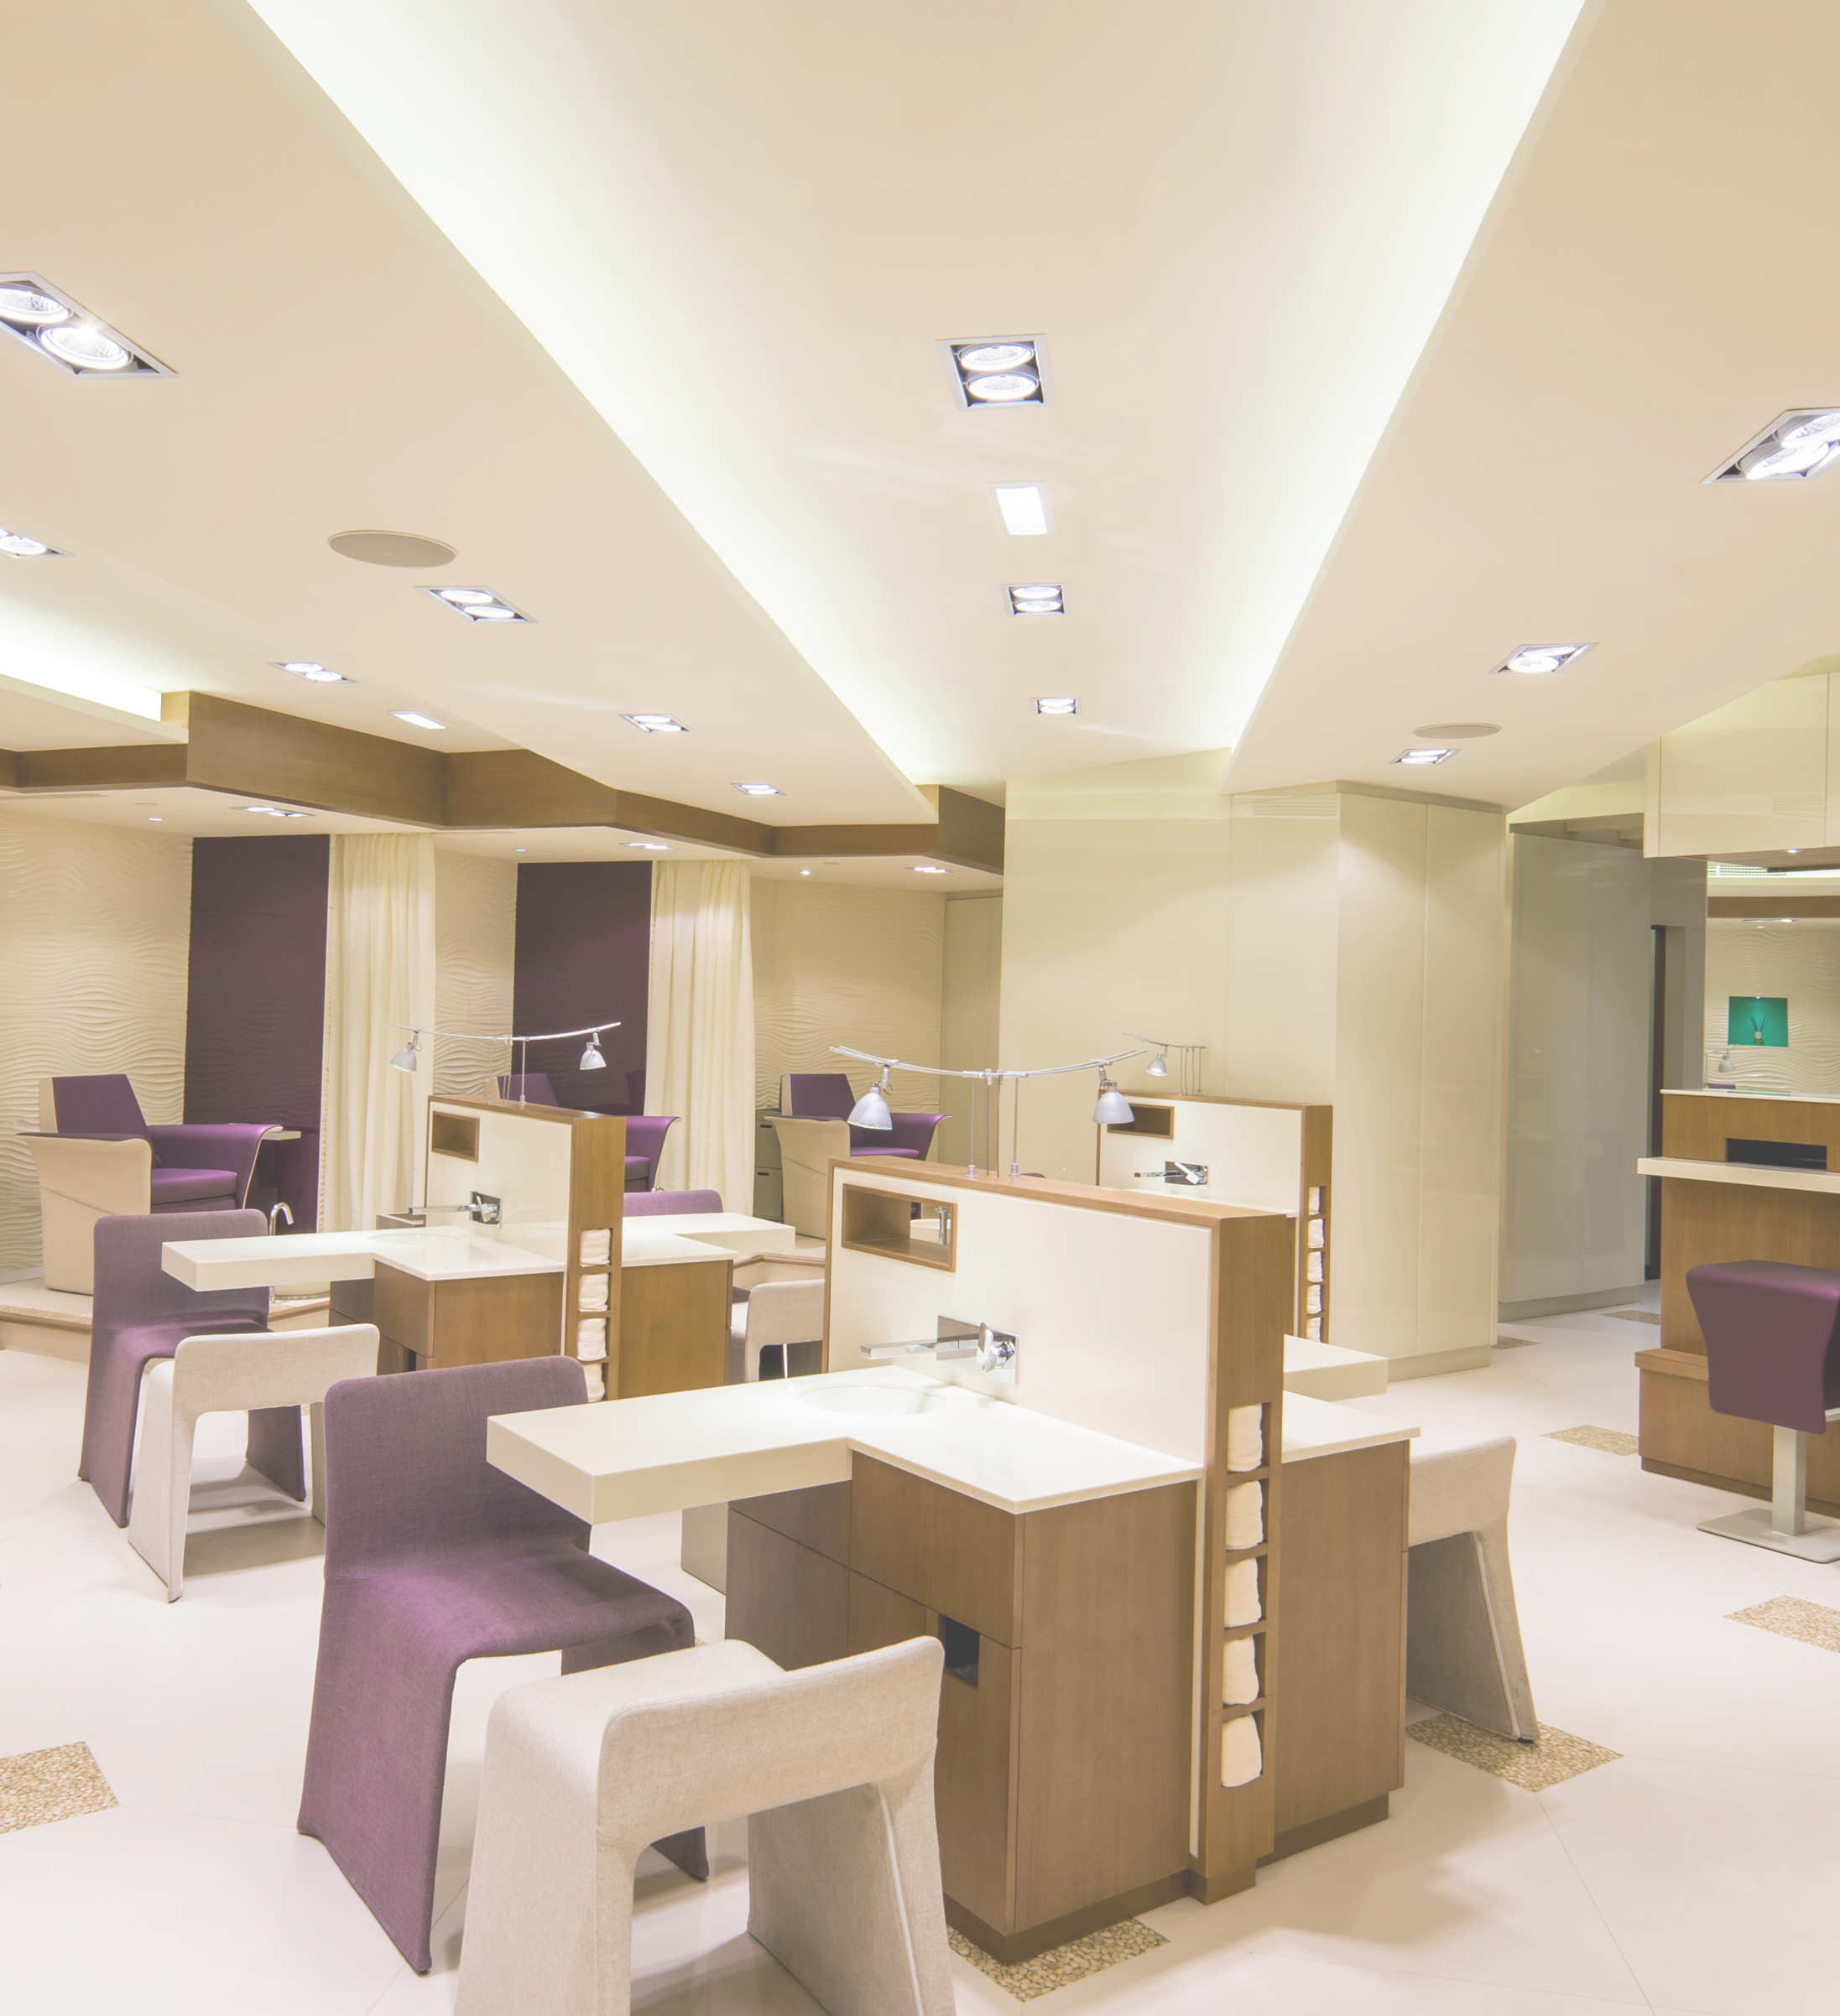THE NAIL SPA began life in 2002 as the region’s first
spa solely for hands and feet: providing “perfection at your
fingertips” for the UAE’s stylish and discerning women. We’ve always listened carefully to our clients and over the years we’ve expanded our service offering
to deliver more spas in the best
locations with the finest range of beauty services and treatments
from around the world.
In 2013 we decided it was time to refresh and reinvigorate our home grown spa brand to reflect
on the outside how we are on the inside. The rejuvenated look and feel – TNS – was applied to each of our spas and today our clients continue to enjoy the relaxing and stylish environment for which we’re renowned.
As part of our brand refresh we expanded our menu and service offerings to include a wide variety of new and improved treatments.
Today, in addition
to our essential nail care, we now offer :
- therapeutic treatments for
hands and feet.
- facials and body massages.
- waxing and threading.
- eyelash and eyebrow tinting.
TNS is part of the HOUSE OF ENSPA family, a holding
company for TNS, MARQUEE
– a premium chain of hair salons, and ESPAI – a dedicated distribution, training and franchising division. The award- winning HOUSE OF ENSPA collection:
- operates 13 spas and salons
- comprising 16,000 sq. ft. retail
and operating space,
- employs more than 350 members of staff – each dedicated to offering a flawless, consistent and holistic customer experience.

A Brand with a Mission

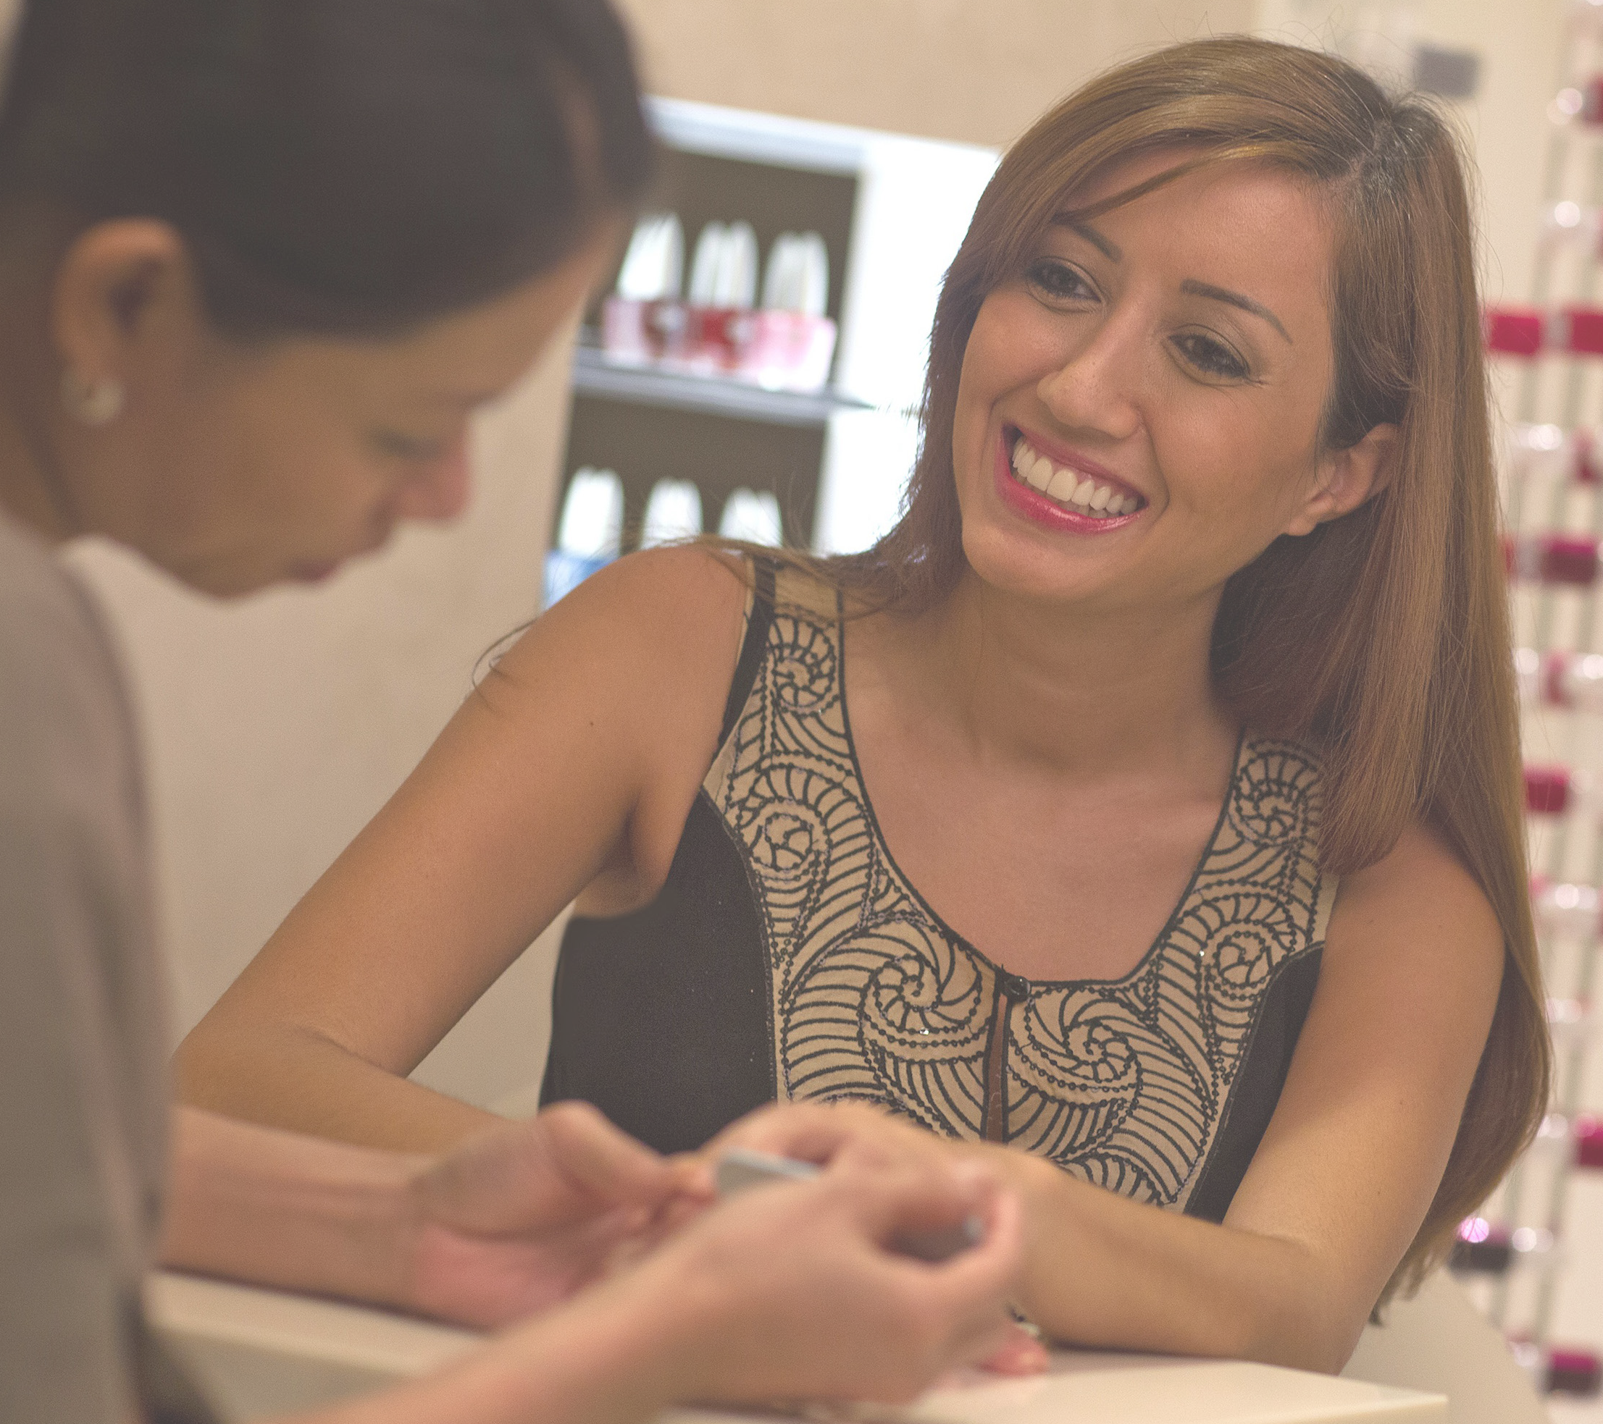We believe passionately that everyone is naturally beautiful. ‘Quintessential Beauty’, as we like to call it, is an attitude, a
feeling, a state of mind. It’s brought to life by the caring touch, knowledge and well- honed skill of our therapists.
At The Nail Spa we are on a quest to:
  - To promote beauty
through happiness
  - Evoke natural beauty
  - Engage at emotional
level with clients
  - To be known and respected as experts and trend setters
  - A place to be seen at – where everyone wants to hangout
  - To be recognised for doing what’s right for our people, our clients, our community and our planet
The Nail Spa profoundly
represents the ongoing attempt of women to achieve the state of ‘just being’ and to lead
complete and fulfilling lives. The brand is a celebration of inner beauty and a tribute to
the women across all ages and times who have been beautiful
through being humble, kind and charming – with an attitude.

Delivering delight

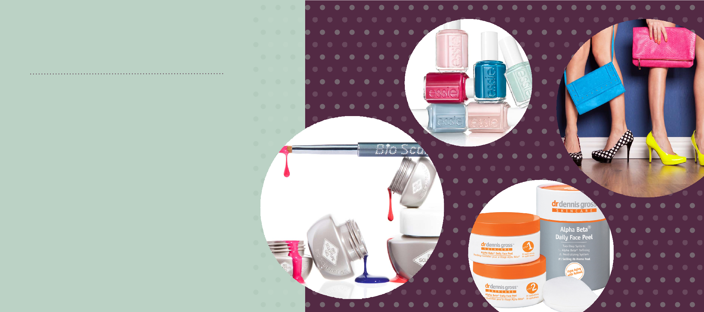
Our team travels here, there and everywhere in search of products and services to add to our tried and trusted favourites: Bio Sculpture, Essie, and Heaven by Deborah Mitchell.
As part of our brand refresh
we introduced new products and services including exclusive in- chair facials from ‘skin-doctor-to- the-stars’
Dr. Dennis Gross, our brand new Let’s Go Lashes service, and the revolutionary Cirépil Wax by Perron Rigot.
Our services include nail care and nail art, therapeutic treatments for hands and feet, facials and body massage, waxing, threading, and eyelash and eyebrow tinting.

Reaching out

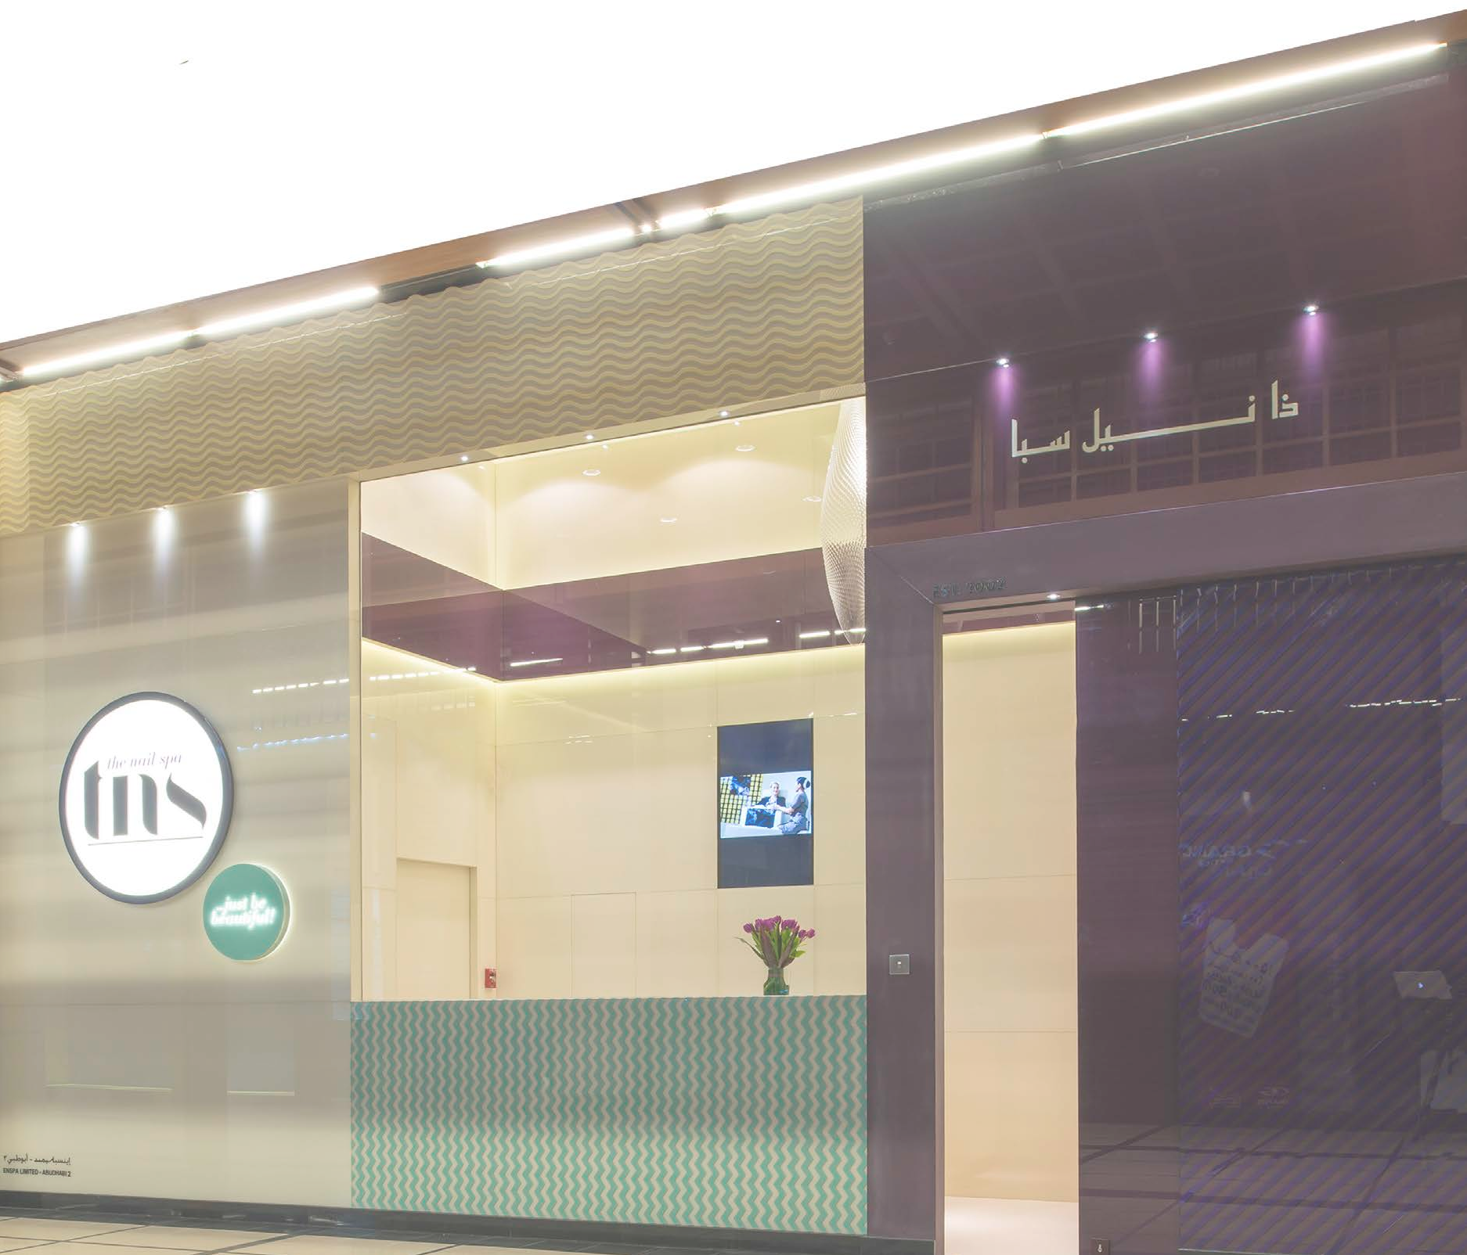Our spas are a haven of relaxation and tranquillity for our customers, but behind the scenes our man- agement team works tirelessly to bring our incredible service offer- ing to an ever-wider audience.

In 2014 we opened a new spa at The Lakes in Dubai’s Emirates Hills, increasing our complement of spa locations to ten.
Abu Dhabi is essential to our expansion plans; we introduced our first spa to Abu Dhabi in 2012, and hot on its heels we comple- mented this offering with two more. By bringing our number of Abu Dhabi spas to three, we are making The Nail Spa ever more accessible to ladies across the UAE. We are also actively inves- tigating bringing our gorgeous brand of beauty to other cosmo- politan cities within the Middle East and are in the process of developing a franchise model.
Our spirit of achievement was fur- ther acknowledged when we were ranked 35th at the 2013 Dubai SME 100 Awards.

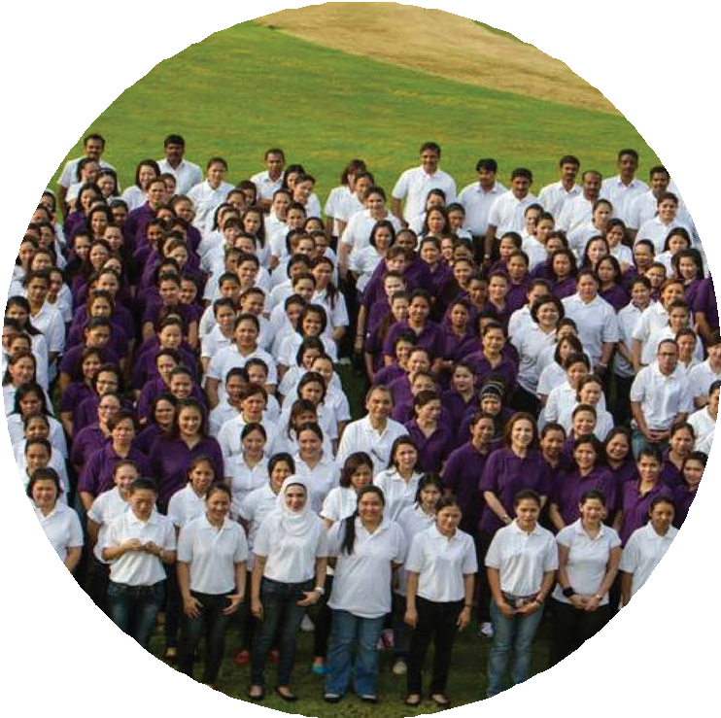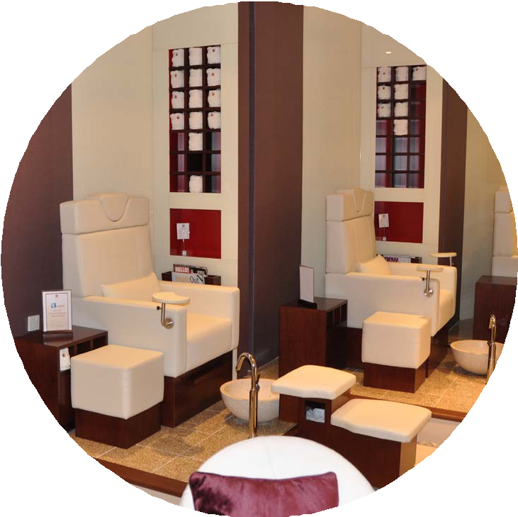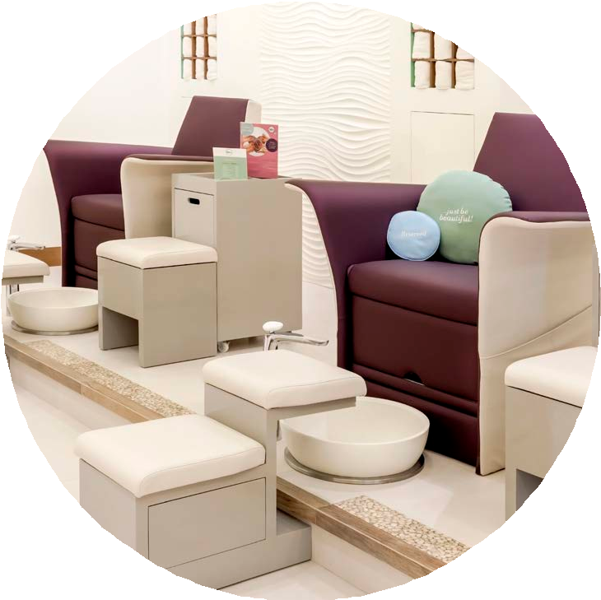

Our journey

DUBAI
Mercato Mall | 2002
The Aviation Club | 2005
Ibn Battuta Mall | 2005
Dubai Mall | 2009
Meadows Town Centre | 2012
Arabian Ranches Golf Club | 2012
The Lakes Club | 2014
ABU DHABI
Al Wahda Mall | 2012
Eastern Mangroves Promenade | 2013
World Trade Centre Mall | 2013

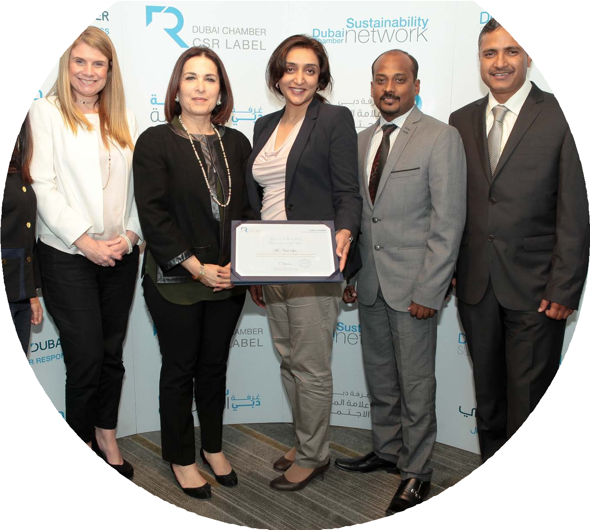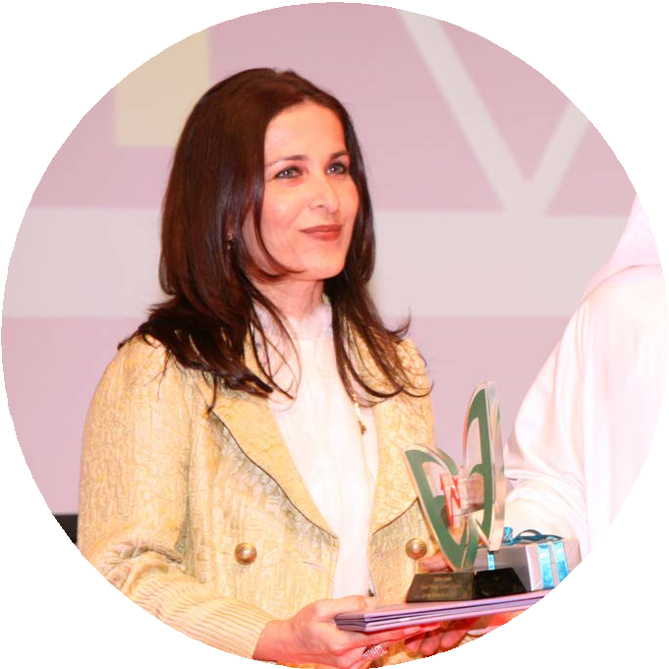

Awards & accolades

Our ongoing success has been recognised in numerous ways, proving that beauty and brains are a great combination.

‘Best Nail Bar’ by VIVA Magazine (2008, 2009, 2010)
    - ‘Business Woman of the Year’ (Shabana Karim) by Dubai Quality Group (2010)

‘Best Salon of the Region’ by Essie (2011)
    - ‘Industry Award Winner for Health & Wellness’ by SME Stars of Business Awards (2011)

‘Admirable Woman Entrepreneur of the Year’ (Shabana Karim) by SME Stars of Business Awards (2011)
    - ‘Corporate Social Responsibility Label’ by Dubai Chamber (2011, 2012, 2013)

‘SME Top 100 Business (ranked 35th)’ by Dubai SME 100 (2013)

Dubai SME100 identifies the top-performing SMEs in Dubai to help groom them into bigger and
more sustainable enterprises, and to support them in their growth into larger and internationally-oriented companies. More than just a ranking, the objective of Dubai SME 100 is to inspire SMEs that have the potential to be world-class enterprises to invest in innovation and people, and to sustain growth.

The secret of our success

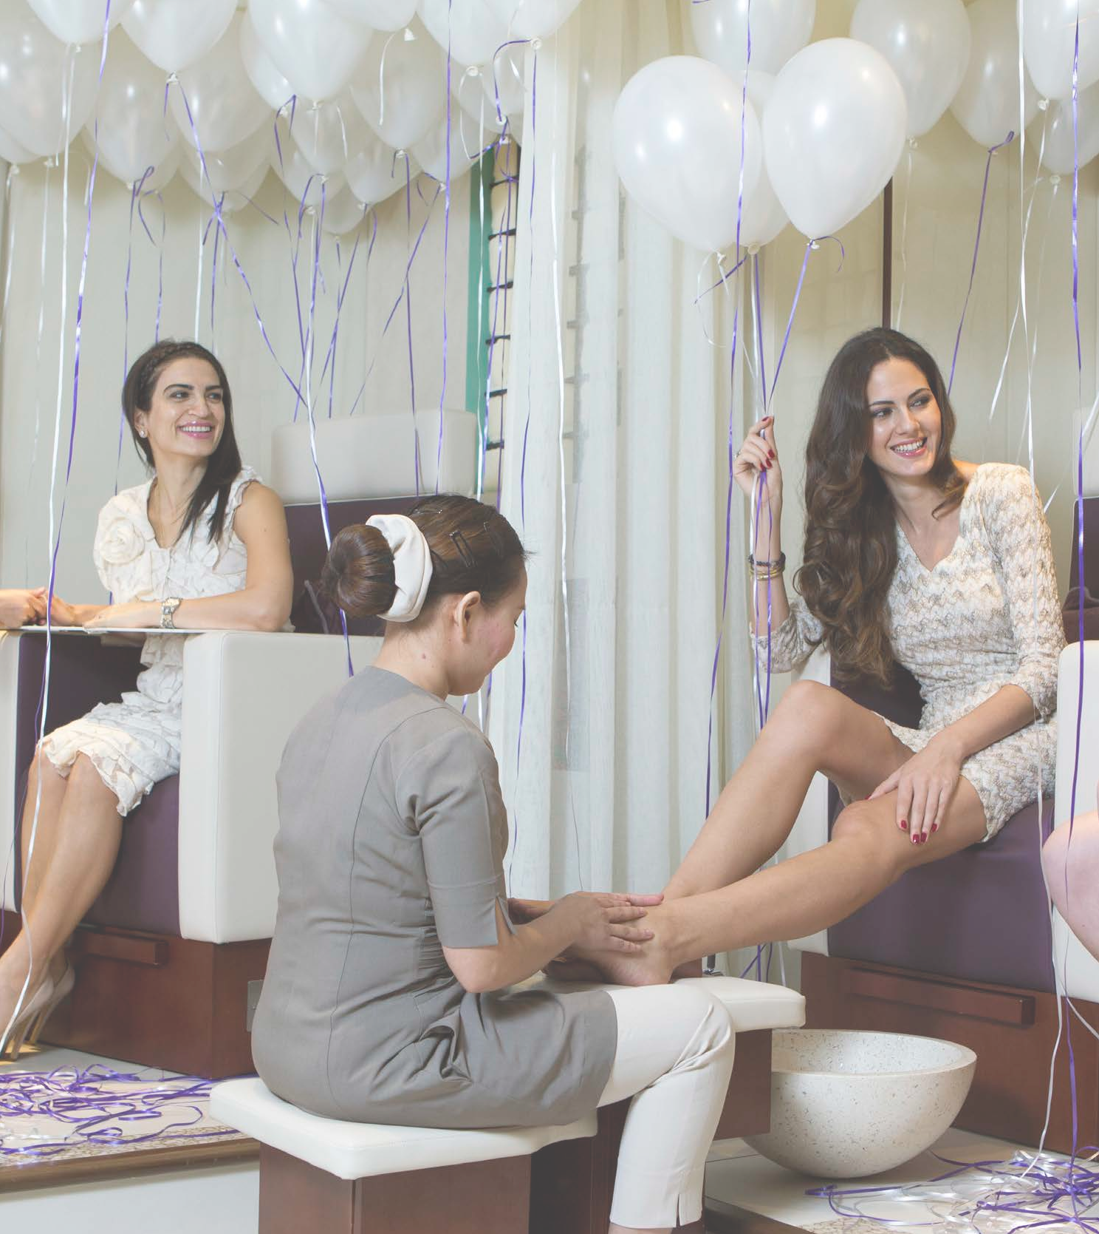CHERISHING OUR CUSTOMERS
We believe that the best marketing tool we can possibly have is a happy customer. We strive every day to make our clients feel valued and cherished, and they reward us by sharing their experience with friends and family. By continually engaging with customers, delivering innovative new products and services, and focusing on consistent quality of service, we have developed a huge following of quintessentially beautiful women who simply won’t go anywhere else.

Thanks to these delighted devotees our business is thriving – but we refuse to take this success for granted.

We work around the clock in search of new ways to
delight our customers, and our objective is encapsulated in our motto: …just be beautiful!

The secret of our success

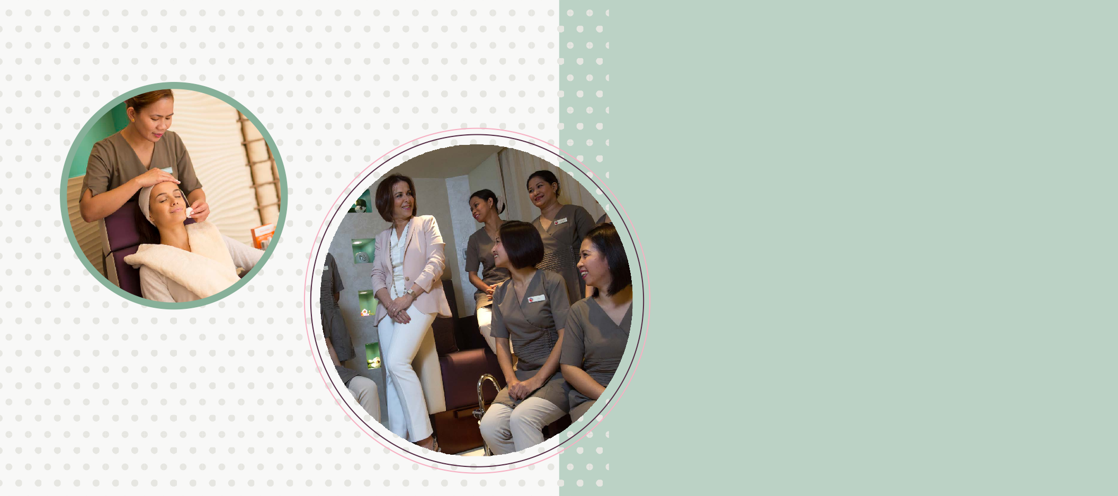
SUPPORTING OUR STAFF

We believe that for us to succeed, our people must succeed. The well-being of our team is at the heart and soul of everything we do, and this is why we are proud to have one of the highest employee retention rates in the beauty industry. We maintain this achievement by running a performance management programme that fosters an environment of openness and transparency across the board. We constantly develop new ideas to support staff happiness, and believe that our focus on training and career development will help us continue to attract and retain top talent at all levels. We ensure that our team is aligned with our vision, allowing us to work together in passionate pursuit of creating something beautiful, valuable and tangible for our clients.
ORGANIC GROWTH

Our customers are always curious to know why we operate just 10 spas across two cosmopolitan cities. We would love to have a spa in every community – and in time we will – but in order to maintain our focus on uncompromising quality we are implementing a strategy of organic, steady growth. We understand our customers want more accessibility and we have responded with a series of innovative ‘out of spa’ offerings. Our customers can now enjoy a wide range of services in the comfort of their home
or office with our convenient Pampering To Go, Desk Side Revival, and Party Planning services.

Beyond Beauty

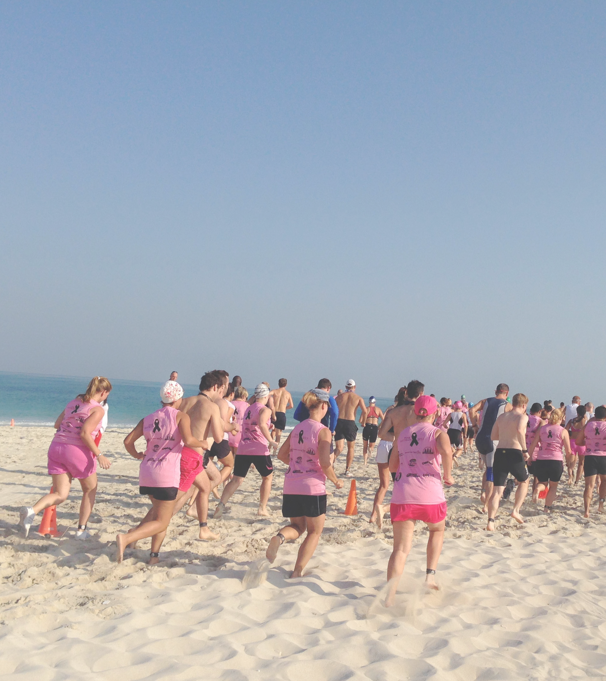We passionately believe that beauty is more than skin deep, and since we first opened our doors in 2002, we’ve woven this belief into everything we do.

We know there’s more to life than being pretty and pampered:
      - Staff welfare is at the heart of
everything we do.
      - We love our team as if they were our own family, teaching our therapists lifelong skills at our beauty boot camp and providing scholarship opportunities for their children.
      - We love our community and are actively involved in local charity
fundraising campaigns and other neighbourhood events.
- We love our planet, sourcing environmentally-sound products and services wherever we can. And we love our clients, striving every day to make them feel even more valued and cherished.

In 2011 we were the first UAE beauty services company to be certified with The Dubai Chamber CSR (Corporate Social Responsibility) Label and we have retained this certification for three consecutive years.

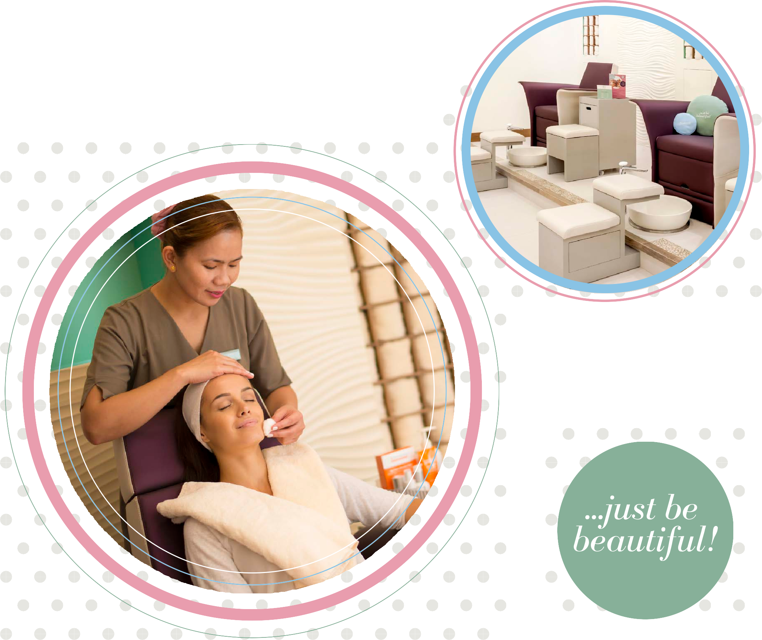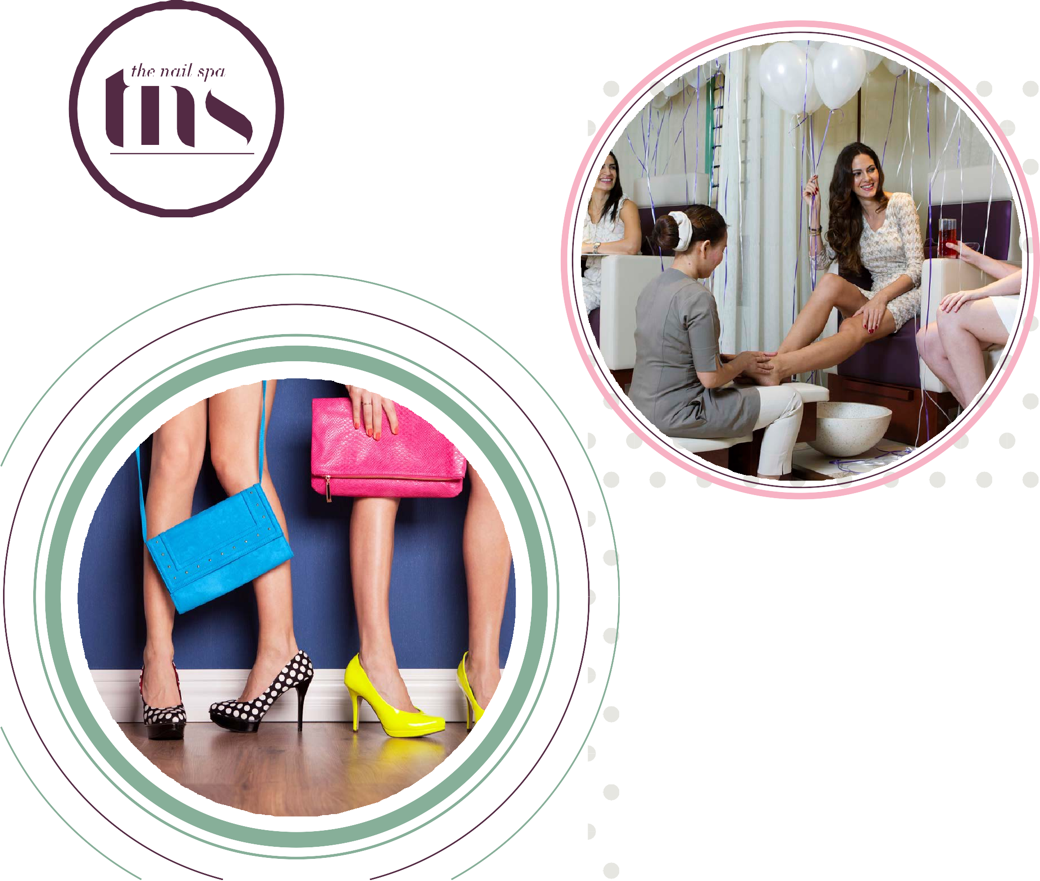

To find out more about exciting TNS business opportunities,

call 04 323 2268 or

e-mail us at: enquiries@houseofenspa.com

www.thenailspa.com

