An Introduction to Our Firm
—

London

Paris
Brussels
Cologne Frankfurt

New York Washington, D.C.

Milan

Rome

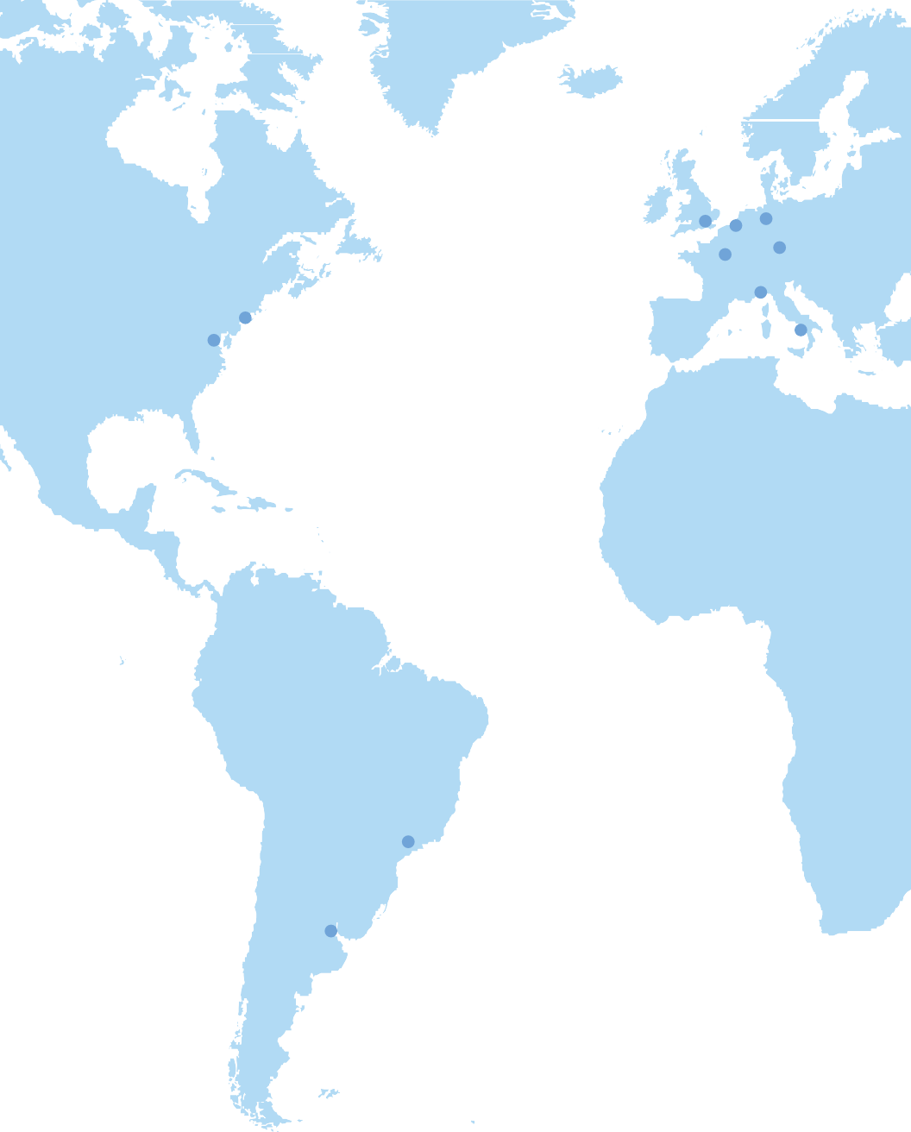

São Paulo

Buenos Aires



Moscow

Beijing
Seoul

Abu Dhabi
Hong Kong

—
In 1946, six distinguished lawyers had the vision to regard the law as a global profession and the courage to create a firm dedicated to the concept that legal excellence can be achieved only when lawyers in a firm cooperate in their practice rather than compete. In so doing, the founders of Cleary Gottlieb created an environment where collegiality, trust and respect are the guiding principles under which we work all over the world today.

A Focus on Excellence


“Cleary Gottlieb has been a global firm since the very beginning, and we understand the value of this for our clients and our culture. We take opening an office seriously and understand the commitment it represents to a region. When you walk into any of Cleary’s 16 offices, you immediately sense that it is part of one integrated firm.”
—
Francesca Odell
Partner
Photo url: https://images.unsplash.com/photo-1521510895919-46920266ddb3?q=80&w=1974&auto=format&fit=crop&ixlib=rb-4.0.3&ixid=M3wxMjA3fDB8MHxwaG90by1wYWdlfHx8fGVufDB8fHx8fA%3D%3D

“You’re dealing with extremely talented people at Cleary. They also understand the practical realities that clients face and are able to respond to questions with those in mind.”
Chambers USA, 2016

Clients trust us to handle their most challenging assignments, whether large corporate transactions, bet-the-company litigation matters or cases of first impression.
#1 Antitrust Practice
VaulŁ Guide Ło Łhe Top 100 Law Firms, 2017
#4
International Law Firm
VaulŁ Guide Ło Łhe Top 100 Law Firms, 2017

#7 Best Law Firm
VaulŁ Regional Guide, New York, 2017
Our work is rarely easy, but we believe you will find it interesting and rewarding. Our lawyers say that what attracted them to Cleary Gottlieb is the opportunity to work on high-profile cases and transactions where the stakes are the highest and where their talents can make a difference in the outcome of a case or
completion of a deal.

Cleary is consistently spotlighted in Law360’s annual “Global 20” survey, which is a ranking of law firms with the greatest global reach and expertise. The firm has been on the list every year since 2011, when the survey was first conducted. Cleary ranks at or near the top of every list measuring law firm success, including Vault, Chambers, The American Lawyer and its “Diversity Scorecard,” and the Financial Times’ “U.S. Innovative Lawyers” report.


“We focus on teamwork and delivering results. It’s all about getting the best possible outcome for our clients.”
—
Jeremy Calsyn
Partner
Photo url:
https://images.unsplash.com/photo-1681971960684-dc7f13925252?q=80&w=1974&auto=format&fit=crop&ixlib=rb-4.0.3&ixid=M3wxMjA3fDB8MHxwaG90by1wYWdlfHx8fGVufDB8fHx8fA%3D%3D

A Pioneer in Globalizing the Legal Profession

We are proud of the way we build our presence abroad. The offices we open in new locations are staffed with homegrown Cleary Gottlieb lawyers, which preserves our culture. Equally important, we bring the talents of lawyers across the firm to bear on issues facing local clients.

We’ve routinely received “matter of the year” and individual lawyer awards from a range of publications, including The American Lawyer, The Asian Lawyer, Asian Legal Business, China Business Law Journal, Euromoney, India Business Law Journal, Institute of Competition Law, International Financial Law Review, International Tax Review, LatinFinance, Latin Lawyer, Law360, LegalCommunity, Project Finance and Turnarounds & Workouts.

“I’ve been resident in Cleary offices in the U.S., UK and Asia—that kind of immersive international experience has made me a better lawyer and impacts how I approach every matter that crosses my desk.”
—
Joshua Frankel
Senior Attorney
Photo url:
https://images.unsplash.com/photo-1544717297-fa95b6ee9643?q=80&w=2069&auto=format&fit=crop&ixlib=rb-4.0.3&ixid=M3wxMjA3fDB8MHxwaG90by1wYWdlfHx8fGVufDB8fHx8fA%3D%3D



“One thing that became clear to me when I was an associate in our Brussels office: Cleary Gottlieb is, to its core, a global firm. The lawyers in our 16 offices have the combination of local and international perspectives needed to do their work at the highest level.”
—
Mark Nelson
Partner

65
languages spoken
50
countries represented
1/3
of our partners have served in two or more of the firm’s offices
Americas Law Firm of the Year
International Financial Law Review, 2015 and 2016
Global 20 Firm
Law360, 2012–2016
Law Firm of the Year
LatinFinance, 2011–2016
South Korea International Firm of the Year
Chambers Asia, 2013, 2015 and 2017
Russian Law Firm of the Year
International Financial Law Review, 2013–2017
Global Elite Firm
Legal Business’ “Global 100,” 2003–2016 (Every year since the list’s inception)


Professional Development and Training

“A core value of Cleary Gottlieb is inclusion, and we have launched a leadership development program with the goal of fostering a professional culture in which all of our lawyers can thrive. The future leaders of the firm are already here — it’s our job to help them reach their full potential.”
—
Breon Peace
Partner


“There is nothing more satisfying than watching junior associates grow and gain confidence in their abilities. I make it a priority to put junior associates in front of the client. They have a fresh perspective and intuit things differently, and they work well with the private equity firms’ junior folks—the decision-makers of tomorrow. It’s a win-win for senior and junior lawyers alike.”
—
Elizabeth Lenas
Partner

We provide training so you can integrate quickly and take responsibility in client matters early in your career.

- All Cleary lawyers spend their first two weeks in our “miniMBA” course, which covers the basics of Wall Street, finance, accounting and other topics usually found in an MBA course.
- First-year associates have access to training covering all of our practice areas.
- We offer a structured curriculum aimed at developing skills such as communication, negotiation, project management, business development, effective delegation, giving feedback and more.
- A rich in-house CLE program is offered throughout the year, with comprehensive courses at all levels in all practices areas.

In addition to our formal training program, you will learn a great deal by doing. As you gain experience and become a more senior associate, you will build your confidence and creativity.



“On almost any day of the week, you can go to a lunch seminar on different topics, which run from the fundamental to the intricate. And our Cleary Core Curriculum helps you transition from being a law student to a practicing lawyer.”
—
Mary Watson
Director of Professional Development


Senior Guidance



“Every partner remembers being an associate and how valuable it was to get hands-on training from colleagues.
I consider passing that along to each group of new lawyers to be both a responsibility and a privilege.”
—
Katherine Mooney Carroll
Partner

Cleary’s lockstep compensation model is based purely on seniority at all levels. We feel this reinforces a culture in which teamwork and the interests of our clients are prioritized. An absence of competition and an environment of collaboration promote enthusiasm for the training and development of colleagues and
the respect of each lawyer’s contributions.

You will receive more than a handshake and an orientation package when you arrive at Cleary Gottlieb. You will start a relationship with an assigned mentor, an experienced lawyer who can guide you through professional and personal life at the firm.
90%
of our current partners joined the firm as associates
Even more important, though, is the day-to-day mentoring you’ll receive working with senior lawyers, advising clients and participating in firm life. And when you choose the practice that will become your specialty, you’ll have additional opportunities to connect with mentors. Lawyers working in the same group take the time to help each other—in meetings, at lunch, in the hallways.
Our approach to mentoring is one that comes full circle. We guide your career ahead and, in turn, eventually you will help new associates advance their careers.


“At Cleary, I have been able to develop my workflow both through formal staffing channels and the relationships I’ve built. I have always known who to turn to if I wanted work in a particular practice area or with a particular person.”
—
Kimberly Spoerri
Partner

Summer Experience

Your experience in our summer program will be more than academic. You’ll work closely with established attorneys to play a meaningful role in firm matters. Partners and other senior lawyers supervise your work, and associates from our Summer Program Committee mentor you.
Your summer associate experience will not be confined to New York or Washington,
D.C. International assignments are plentiful; in past years, more than one-third of our summer associates have spent time working in Cleary’s overseas offices.
Training ranges from formal to informal. We offer litigation training, oral argument exercises, “Wall Street Lunches” and corporate practice seminars, all of which are targeted specifically to summer associates. In addition, summer associates are invited to attend casual presentations that introduce them to practices throughout the firm as well as the lawyers in each area.
We also encourage learning more about New York City and Washington, D.C. through numerous local events, including partner-hosted dinners, theater, sporting events, concerts and karaoke.


“Working as a summer associate is not only a great learning experience for law students, it’s also an immersive experience in the life and culture of a law firm. You have the opportunity to work closely with attorneys across different practice areas and to socialize more informally at events. You’ll get a true feel of what it’s like to be a Cleary lawyer.”
—
Lisa Schweitzer
Partner



“The work experience that summer associates get is completely authentic. It’s what attorneys will do when they start full time, and it’s
the work I do on a daily basis.”
—
Deborah Francois
Associate
26
schools are represented by the students in our summer class

49%
of our summer class participated in our overseas rotation program


“The summer program provides an opportunity to experience the firm’s one-of-a-kind culture. I got to both develop my skills as a lawyer and do hands-on work with my future colleagues.”
—
Macey Levington
Associate

Recent Accolades and Awards

Our clients call on us when simple solutions will not do. We represent multinational corporations, international financial institutions, sovereign governments and their
322
practice and lawyer rankings earned in the Chambers Global 2017 edition
60
of these rankings were top tier
80%
of partners recognized by Chambers
agencies, and domestic corporations and financial institutions in the countries where our offices are located.

Top 25 U.S. Firm
(Selected by General Counsel) NYSE Governance Services and FTI Consulting Inc.’s “Best Corporate Law Firms,” 2016

“Everything we do is ultimately focused on delivering first-rate services to our clients, who come to us for their most demanding matters. Job No. 1 is to get it right.”
—
Steve Wilner
Partner



“We know that clients come to Cleary for elegant and creative solutions to complicated problems. I love working on those challenges and delivering above and beyond our clients’ expectations.”
—
Elaine Ewing
Partner

Recent notable achievements and awards include:

100% Coporate Equality Index
Human Rights Campaign, 2016 and 2017

Arbitration Law Firm of the Year
LegalCommunity, 2017

A-List Law Firm
The American Lawyer, 2016

Antitrust/Regulatory Firm of the Year
LegalCommunity, 2016

Investment Funds Firm of the Year
Chambers USA, 2016

Financial Regulation; M&A; Private Equity; Restructuring; and Debt and Equity-Linked Teams of the Year
International Financial Law Review, 2016

White-Collar Crime, Enforcement and Securities Firm of the Year
Benchmark Litigation, 2016

Antitrust Firm of the Year
Chambers USA, 2015



Your Career at Cleary Gottlieb and Beyond

For more than 70 years, Cleary has been turning out some of the best and brightest lawyers and leaders.

We understand that a law firm job can provide the training that springboards you to a career in an entirely different field, from academia to business to not-for-profit work.
We’ll talk openly with you about the possibilities inside and outside Cleary Gottlieb. But we’ll do more than help you assess your options—we’ll help you reach your goals.
If the path you choose points to a long-term career at Cleary, we’ll provide the training and mentoring to make you a strong candidate for senior attorney, counsel
or partner.
If you decide to look outside Cleary, we’ll help you build a résumé that can lead to the right opportunity. And we have an impressive network of alumni and clients who regularly call us to fill positions in their organizations.
We are looking for attorneys who can excel in the law as well as in business, academia, government service and beyond.



Our network of stellar alumni is among our proudest achievements. The range of positions that our alumni hold
reflects both the quality of Cleary’s legal training and the diverse interests of our lawyers.
We count among our alumni:
50
founders or current directors of not-for-profits
20
judges, including a Justice of the U.S. Supreme Court
450+
banking and finance executives
60
officials at intergovernmental organizations
75+
hedge fund and private equity executives
35+
startup and technology company leaders
200
general counsel and senior officers at Fortune 500 companies
400+
in government
240
law professors

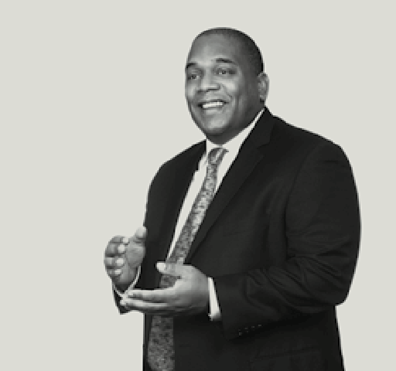


Chinyelu Lee
Jane Song
Katie Dunn



Larry Malm
Margot Gianis
Adrian Ntwatwa


Jenny Paul
Christopher Condlin





Tumi Adebiyi
Adam Jamal
Contact Us
NEW YORK
Donna Harris
Director of Legal Recruiting
T: +1 212 225 3170
F: +1 212 225 3999
nyrecruit@cgsh.com
WASHINGTON, D.C.
Georgia Emery Gray Director of Legal Personnel and Recruiting
T: +1 202 974 1804
F: +1 202 974 1999
gegray@cgsh.com
For more information on our New York and Washington, D.C. offices, please visit: https://www.clearygottlieb.com/careers/ny https://www.clearygottlieb.com/careers/dc

Brand images:
main photo url:
https://images.unsplash.com/photo-1505664194779-8beaceb93744?q=80&w=2070&auto=format&fit=crop&ixlib=rb-4.0.3&ixid=M3wxMjA3fDB8MHxwaG90by1wYWdlfHx8fGVufDB8fHx8fA%3D%3D

Brand music:
/music/ClearyGottlieb.mp3
Style to be applied:
<style>
body {
background: linear-gradient(rgba(0, 0, 0, .5), rgba(0, 0, 0, .5)),
url(‘https://images.unsplash.com/photo-1535905313417-483b22cb9d03?q=80&w=1974&auto=format&fit=crop&ixlib=rb-4.0.3&ixid=M3wxMjA3fDB8MHxwaG90by1wYWdlfHx8fGVufDB8fHx8fA%3D%3D’);
background-attachment: fixed;
background-position: center;
background-size: cover;
color: #fff !important;
}
</style>

Contact information:
Calendly username:
“clearygottlieb”
Contact email address:
“info@clearygottlieb.cloud”

Website url:
clearygottlieb.com
17.0316.59_081717

